Student Worksheet: Analyze a clinical trial’s result
Directions: Read the graph summary and answer the questions below in the sections “The basics” and “Analyzing the data.” Then read the Science News article “A gene editing technique shows promise for lowering LDL cholesterol” and answer the final set of questions titled “Understanding VERVE-101.”
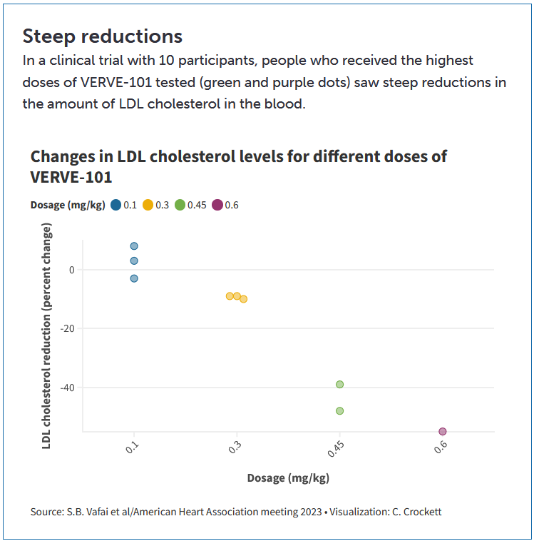
The basics
1. Define what is reported on the x-axis and y-axis. Be sure to include the units.

2. What does a negative percent change indicate on the y-axis? What does a positive percent change indicate?

3. Explain the x-axis unit mg/kg. What do you think it means in this study?

4. What were the doses of the drug, and how many patients received each dose?

5. Explain what the one purple dot indicates.

Analyzing the data
1. What is the graph’s general trend?

2. From the data, would you say that the 0.1 mg/kg dose was effective in lowering LDL levels in the blood? Explain.

3. Explain the range or spread of outcomes for patients who received the 0.3 mg/kg dose. How does this compare to patients who received 0.45 mg/kg? What about the 0.6 mg/kg dose?

4. If you were running another clinical trial of this drug, based on these data, which doses would you administer to patients? Explain your reasoning for each dose given in the previous trial.

5. What other questions do you have about the doses given in the first trial? What other information would you need to make dose suggestions for a future clinical trial?

Understanding VERVE-101
1. What disease does VERVE-101 target?

2. Describe how VERVE-101 works. What technology is involved? Draw a simple diagram of how the medicine works within the body.

3. What are possible benefits of VERVE-101 based on the clinical trials highlighted in the article?

4. What are some possible risks of VERVE-101, based on the clinical trials highlighted in the article?

5. What are the next steps involved in the process of getting VERVE-101 out to people who need it? Why are these steps necessary?

