Student Worksheet: Cannabis and the Teenage Brain
Directions: Read the online Science News article “The teen brain is especially susceptible to the harms of THC.” Then answer the following questions as directed by your teacher. Because the article is long, the questions are broken up by the article’s subheadings.

Before Reading
1. Discuss the following question as a class. Frequent use of which of the following could pose a high risk of harm to you? Ask students to rank the following substances from most harmful to least: cigarettes, alcohol, cocaine, heroin and cannabis.

2. Human brains carry out a lot of growth and development during adolescence. With this in mind, how important is it to make healthy brain decisions during our teen years versus when we are adults? In other words, is it more, less, or equally important for us to make healthy decisions as teens and adults, based on what we know about brain development? Explain your answer.

During Reading

Introduction
1. What percent of 12- to 17-year-olds perceive “great risk of harm” from smoking marijuana once or twice a week?

2. What idea does the widespread availability of cannabis for adults promote in young people, according to Beth Ebel?

3. What is the full name and abbreviation of the main psychoactive chemical in marijuana plants? How has the percentage by weight of this chemical in the marijuana plant changed in the past few decades?

“How does THC affect the teen brain?”
1. Why is adolescence a risky time to be using cannabis, according to Yasmin Hurd?

2. Describe three aspects of human function that are influenced by the endocannabinoid system.

3. Describe how THC can interfere with the body’s endocannabinoid system. What are some impacts of this?

“Marijuana use is linked to mental health harms”
1. What is cannabis-use disorder?

2. Researchers studied rates of depression and suicidal thoughts among adolescents who consumed cannabis. Those who used the drug had a higher prevalence of depression and suicidal thought then did those who didn’t. Now refer to the graph, “Cannabis and mental health.” Provide data from it that supports the researcher’s claim.

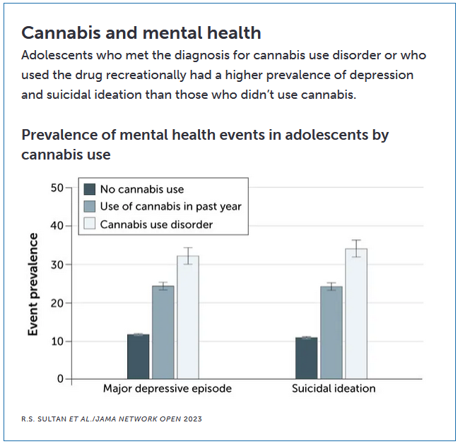

3. What does the article highlight as possible future consequences for teens who become dependent on marijuana at a young age?

“The risks of using concentrated cannabis products”
1. According to a 2020 study, how did preferred methods of cannabis consumption by teens change from 2015 to 2018?

2. What is “high-potency cannabis?”

3. What are some risks of using high-potency cannabis? Why do Ebel and Hurd argue that high-potency products are alarming?

After Reading
1. Why might today’s teens be at even greater risk from cannabis use compared to teens in the past? Refer to information from this article to support your answer. To what extent might this greater risk lead some adults to misunderstand risks of cannabis use by kids?

2. This article describes various studies supporting the conclusion that THC causes harm to developing brains. Pick one of these studies and explain how the evidence from this study supports the conclusion that THC can harm the teenage brain.

