Student Worksheet: Data on dwindling migratory species
Directions: Using only the graphs “Danger zone” and “In need of protection” from the Science News article “Migratory fish species are in drastic decline, a new UN report details,” answer the first two sets of questions below as directed by your teacher. Read the article before answering the questions in the third section.
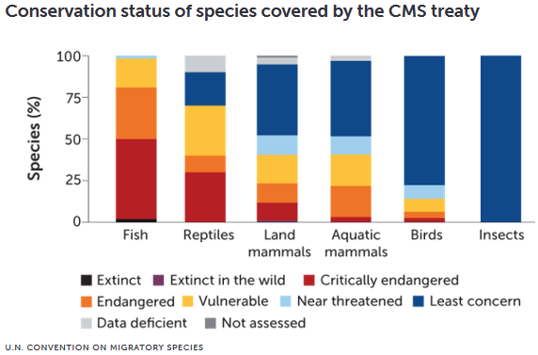

Dig into the danger zone
1. What type of graph is this? What do the bars represent? What is measured on the axes (include units when necessary)?

2. Use the graph to compare the conservation status of migratory fish to birds. Which group is more threatened?

3. How are the bars for animal groups lined up on the graph? Why is the “Fish” bar on the far left and “Insects” bar on the far right?

4. As shown on the graph, how does the percentage of critically endangered reptile species compare with the percentage of critically endangered fish species? What information is missing from the graph that could tell you more about the overall conservation status of different groups of species?

5. What does the graph tell you about the migratory insects included in the treaty? Read the text above the graph and explain why the bar for insects may be misleading.

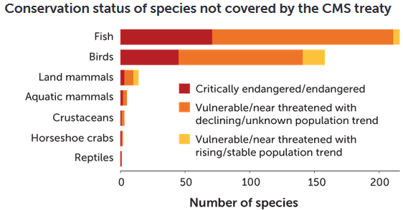

In need of protection
1. Read the text above the graph and explain the type of graph and what is shown in the graph.

2. How are the axes on this graph different than those on the first graph?

3. About how many fish and bird species not covered by the CMS treaty are vulnerable or endangered?

4. If the information from this graph were included in the previous graph, what would you guess would be the most significant change on the graph?

Synthesizing graphs
1. About how many migratory species are known, according to the two graphs? Explain.

2. From your exploration of the graphs, write a brief summary of the data presented in the report. Then read the article and compare your summary to the Science News writer’s. What information wasn’t included in the graphs?

3. What additional information or questions do you have about the data, report or international treaty?

4. What do you think should be the next step? How could this international treaty and report help impact the conservation status of migratory animals at risk? What are some limitations as to what it can accomplish?

