Student Worksheet: Methane in the Atmosphere
Directions: To tackle our warming climate, we’ll need to rein in emissions of carbon dioxide, but there’s another greenhouse gas at play: methane. Decreasing methane concentrations may be the best bet for stopping rising temperatures in the short term. Use the graph “On the rise” to analyze how methane concentrations have changed since 1983. Read the graph title and caption before completing the questions below.
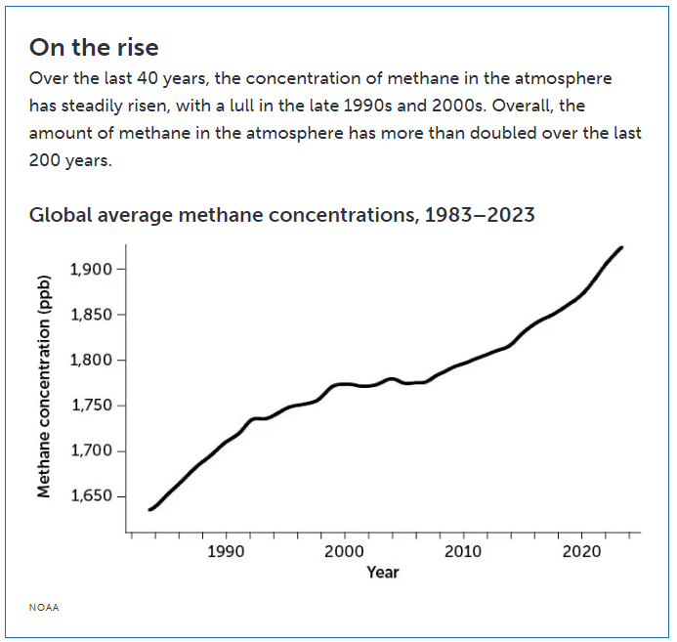
NOAA
Graph Questions
1. What was the approximate methane concentration (ppb) in 2020?
- 1900
- 1850
- 1800
- 1750

2. Calculate the methane concentration rate of change from 2010-2020. Give your answer in ppb/year.

3. If the rate of change remains at the rate from 2010 to 2020, what would be the approximate methane concentration (ppb) in 2030? Once you have your answer, check the graph. Does that estimation look like it will be accurate? Why or why not?

