Student Worksheet: Agriculture may be growing ozone
Directions: The air pollutant ozone has been linked to health problems including respiratory illness, reproductive problems and some cancers. Levels of ozone in the United States have come down over time but have started to rise again in places because of wildfires and soil emissions.
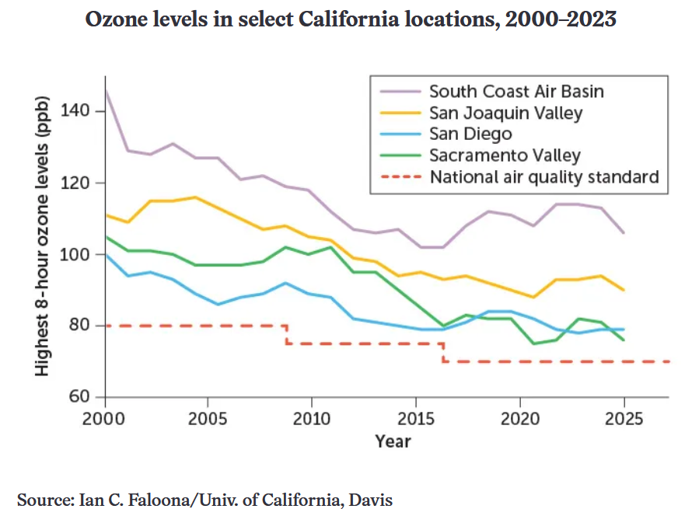

Graph Questions
1. Describe what is shown on the x-axis and the y-axis, including units.

2. Which California air basin is consistently lowest in ozone levels before 2015?
- South Coast Air Basin
- San Diego
- San Joaquin Valley
- Sacramento Valley

3. During what time frame did the Sacramento Valley air basin have the lowest levels of ozone as compared with the other locations?

4. Would you expect an urban area like San Diego to have higher air quality than an agricultural area like the Sacramento Valley? Why or why not?

