**Student Worksheet: Earth and its many layers**

**Directions**: To really understand Earth, you need to travel thousands of kilometers beneath our feet. Starting at the center, Earth is composed of four distinct layers.

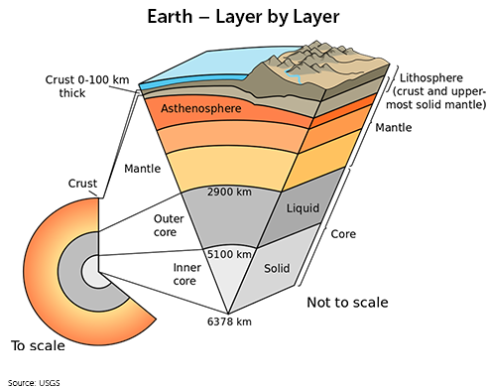

**Graph Questions**1. Which of the following has the layers of the Earth in order from deepest to most superficial?

1. inner core, outer core, crust, mantle
2. inner core, crust, mantle, outer core
3. inner core, outer core, mantle, crust
4. crust, mantle, outer core, inner core

2. The lithosphere is made up of what two layers?

1. mantle and the inner core
2. mantle and the outer core
3. crust and uppermost solid mantle
4. none of the above

3. Which of the layers is the thickest? Estimate its approximate thickness in km based on the visualization.