Student Worksheet: Got stress?
Directions: The sympathetic nervous system — our fight-or-flight response — kicks in when we face a big challenge or risk. When we’re relaxed, our parasympathetic nervous system takes over. Together these two systems make up the autonomic nervous system.
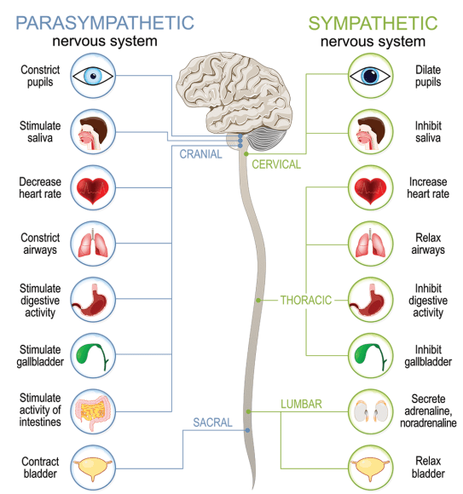
TTSZ/ISTOCK/GETTY IMAGES PLUS

Graph Questions
1. Not counting the cranial area where the spinal cord intersects with the brain, what are the other four parts of the spinal cord in order from anterior (towards the head) to posterior (towards the tailbone)?

2. Which of the following is a true statement? Select all that apply.

- The respiratory system is not affected by stress.
- The circulatory system is not affected by stress.
- The digestive system is affected by stress.

3. How does the parasympathetic nervous system complement the sympathetic nervous system? Provide an example that is related to each of the three main parts of the spinal cord (in green text).

4. Which system is triggered first in response to stress, parasympathetic or sympathetic?

