Student Worksheet: Parachute paleontology
Directions: Fossil research has been plagued by parachute paleontology. This happens when scientists from high-income countries travel to low-income countries to study or collect fossils but don’t involve local experts. Sometimes foreign scientists skirt local laws about exporting fossils or buy them under sketchy or even illegal circumstances.
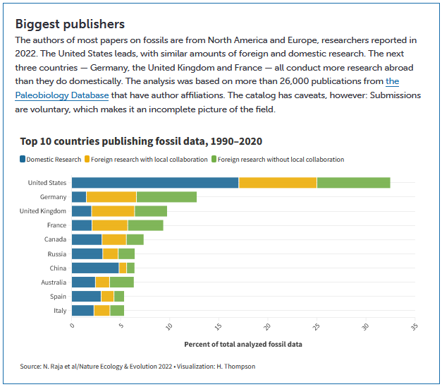
Note: The data visualization is interactive, and students can click on a particular piece of the graphic and get exact % numbers of total analyzed fossil data.
Graph Questions
1. Which countries of North America are extensively involved in publishing fossil data according to the data visualization above?

2. Which of the following statements is true?
a. Germany publishes more domestic fossil research than foreign fossil research.
b. Of all countries, Australia has the most publications using foreign research with local collaboration.
c. Canada publishes more fossil data from domestic research than either type of foreign research
d. China publishes the most fossil data in all three categories of research.

3. How does the amount of domestic research in the United States compare with the amount of domestic research in all the other countries? Why do you think this is?

