Student Worksheet: Renewable power is a bright idea
Directions: Over the past two decades, electricity from renewable sources, such as wind and solar, has been on the rise. Devices known as grid-forming inverters will likely play a major role in getting renewable energy safely into the power grid.
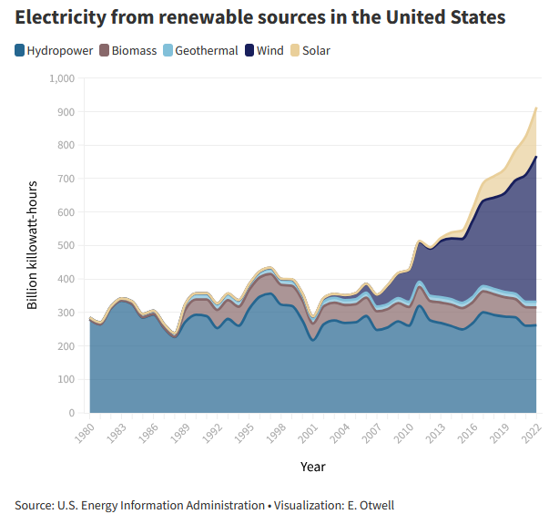

Graph Questions
1. Which type of renewable source appears to be the newest for electricity generation?
- biomass
- geothermal
- hydropower
- thermal
- wind

2. In 2001, which source produced the lowest amount of kilowatt hours? Which produced the most?

3. Which types of renewable energy have increased in usage in recent years? Explain how you know this from the graph. Why do you think this is?

