Student Worksheet: Nuclear testing tally
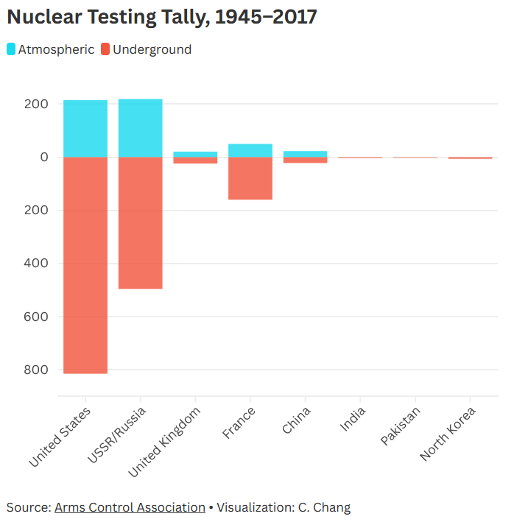
Directions: Beginning with the first test explosion in 1945, more than 2,000 atomic blasts have rattled the globe. Nuclear testing dwindled after a treaty in the 1990s. Recently, some in the United States have called for resumed testing, which could have serious consequences for the environment and global politics.

Graph Questions
1. Which country has conducted the most nuclear testing overall (both underground and atmospheric)?
- China
- India
- France
- North Korea
- Pakistan
- United Kingdom
- United States
- USSR/ Russia

2. TRUE/ FALSE: There have been over 1,400 nuclear tests conducted underground.

3. Describe how nuclear testing could affect an ecosystem. For example, how could it affect plants? How could it affect animals?

4. What type of data visualization is this, and why do you think it was chosen to display these data?

