Student Worksheet: Lunar landforms
Directions: Researchers analyzed images of giant canyons on the moon to deduce the physics of how they formed. A massive impact 3.8 billion years ago shot out rock that plunged 3.5 kilometers into the lunar surface, carving two canyons in less than 10 minutes.
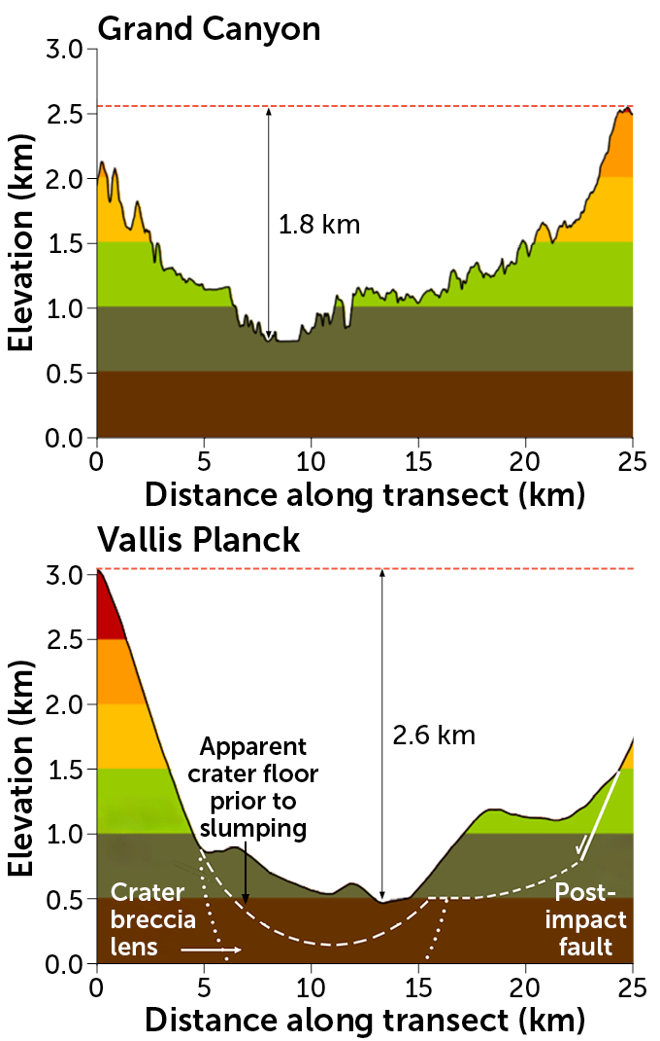
DAVID A. KRING, DANIELLE P. KALLENBORN, AND GARETH S. COLLINS

Graph Questions
1. Looking at the data for the Grand Canyon, the tallest point in elevation is approximately how many meters?
- 500 meters
- 1,000 meters
- 1,500 meters
- 2,000 meters
- 2,500 meters

2. Between what distances along the transect is the Grand Canyon the deepest?
- 0-5 km
- 5-10 km
- 10-15 km
- 15-20 km
- 20-25 km

3. Which canyon is deeper, the Grand Canyon or the Vallis Planck?

