Student Worksheet: Sink or Swim: Exploring Bone Density and Buoyancy
Directions: Based on recent research, Spinosaurus is depicted swimming in the newest Jurassic World movie. Some studies point to Spinosaurus’s relatively dense bones, which could have helped control buoyancy for swimming. But others argue that Spinosaurus fossils point to its life as a wader.
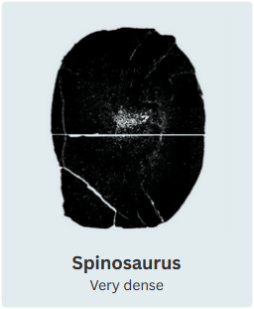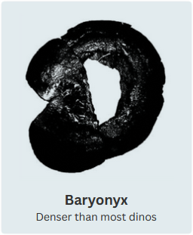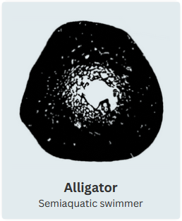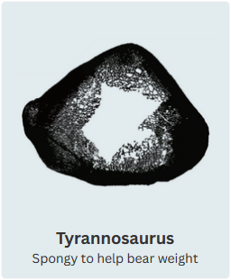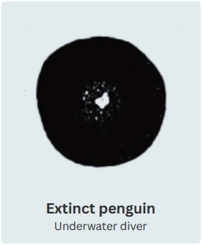
Fabbri et al.
Graph Questions
1. Of the organisms pictured above, which one has the densest bones?
- Puffin
- extinct penguin
- swan
- alligator
- Tyrannosaurus
- Spinosaurus

2. An extinct penguin has denser bones than a puffin. What evolutionary advantages might this provide the puffin?

3. What physical or behavioral characteristics of an animal might be a result of the animal’s bone density?

