Student Worksheet: Using smartphone data to probe the ionosphere
Directions: A sea of charged particles swirls in the ionosphere, a layer at the edge of Earth’s atmosphere. Shifts in the ionosphere can muddle radio signals key for navigation systems. But pooling data from millions of phones equipped with GPS receivers could help fix errors caused by the meddlesome atmospheric layer.

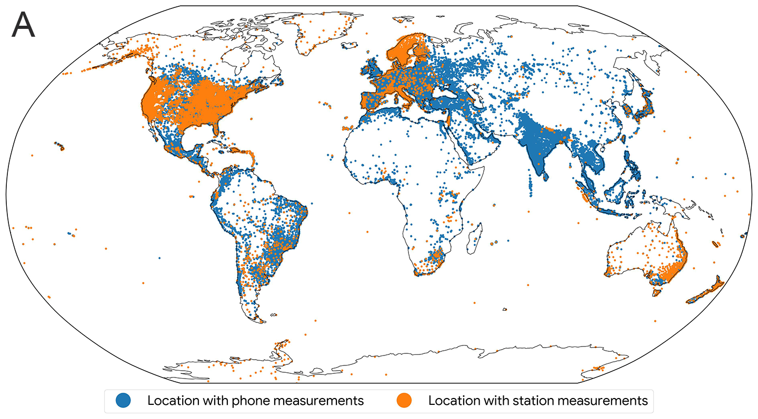
Researchers compared maps made with measurements from phones and monitoring stations. They used data from some 9,000 monitoring stations (orange dots). At around 100,000 locations, there was enough data from smartphones to map the ionosphere (blue dots).
GOOGLE

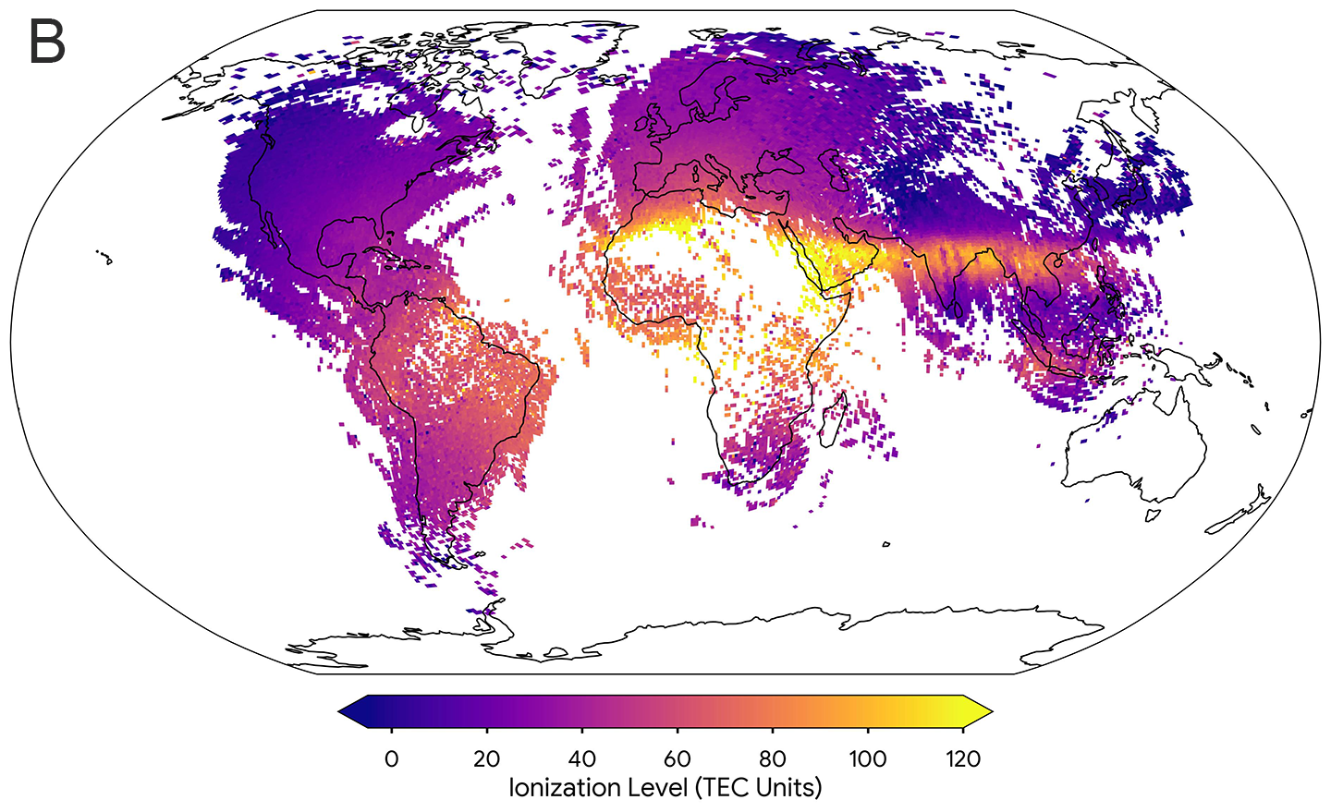
Researchers made this map of the ionosphere using 10 minutes of phone data from October 12, 2023. It shows levels of ionization, or how much charge is hanging around. Ionization is measured in TEC, or total electron count, units. TEC units describe the number of electrons not attached to atoms in a square meter of the atmosphere. Higher levels of TEC units correspond to greater ionization. The map shows what’s called the equatorial anomaly. This is a band of more intense ionization around the equator that dips south over South America.
GOOGLE

Graph Questions
1. Which source of data is the most abundant across the world according to Figure A: measurements from monitoring stations or from smartphones?

2. Which continent has the least amount of cell phone data points? Why do you think that is?

3. Describe what is being measured in Figure B. How does it relate to Figure A?

