Student Worksheet: The weight of weight-loss drug usage
Directions: Shortages and big price tags have driven patients to unconventional, sometimes shady sources of weight-loss drugs. In some cases, people end up with tainted drugs or risk overdosing.
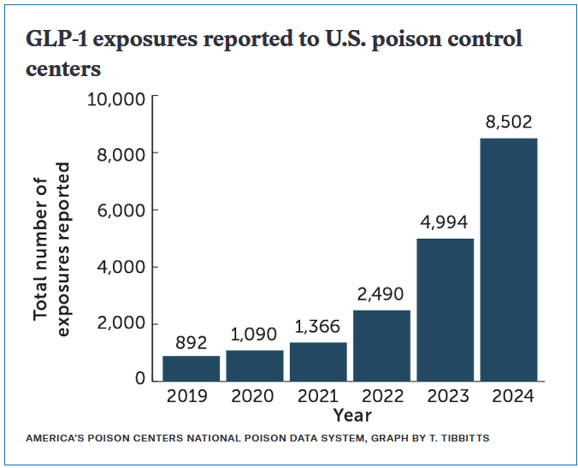

Graph Questions
1. In what year have the most GLP-1 exposures been reported to U.S. poison control centers?

2. Compared with 2019, how many more incidents were reported in 2024? Give your answer as number of incidents and the percent increase.

3. How do you think social media has contributed to the increased use of weight-loss drugs over the past 5 years?

