Student Worksheet: Aerosols in the air: Art in motion?
Directions: The atmosphere abounds with aerosols, tiny particles with large sway over global temperature. A new visualization from NASA reveals how these airborne particles swirl through Earth’s sky. View the visualization video in the Science News article “See how aerosols loft through Earth’s sky”.
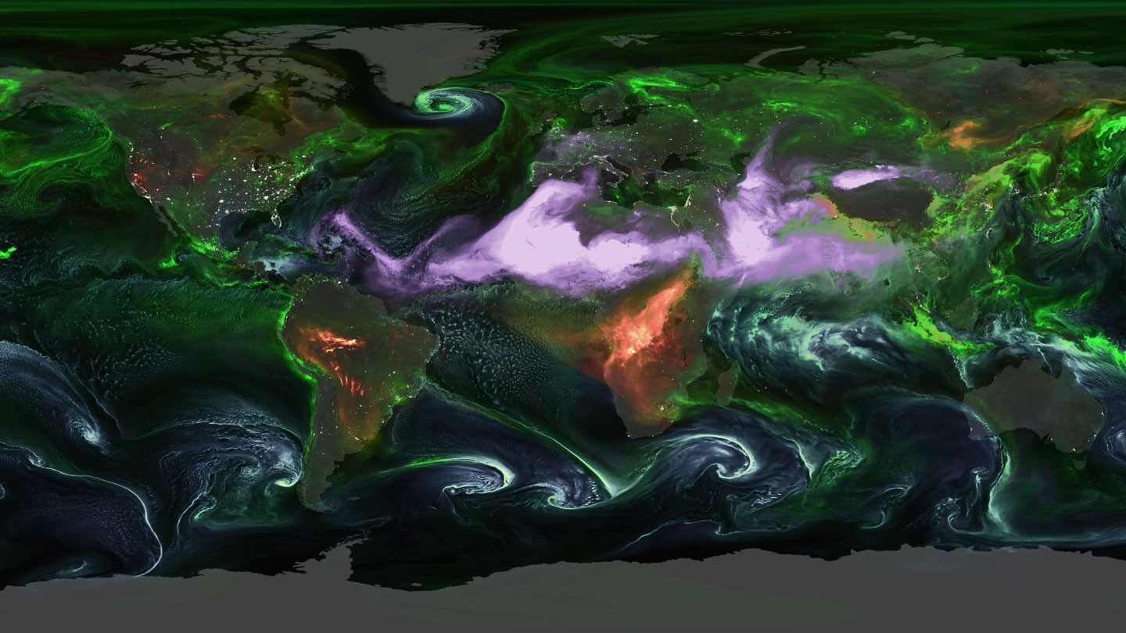
NASA’s Global Modeling and Assimilation Office and NASA’s Scientific Visualization Studio
Green = sulfates Purple = dust Red = black carbon Teal = sea salt

Graph Questions
1. Sulfates are often linked to fossil fuel burning. Many countries, including the United States, have curbed coal usage. Based on what you can tell from the map, name one continent that still has high levels of sulfate aerosols.

2. Where does most of the atmospheric dust come from??

3. Black carbon (red) is emitted by burning biomass, such as trees and plants. What are the two continents with the highest level of black carbon aerosols?

4. The abundance of sea salt (teal) is tied to wind speed. Why do you think higher wind speeds are correlated with more sea salt aerosols? Why do you think the concentration is highest in the Southern Ocean

