Student Worksheet: Earth’s history of temperature shifts
Directions: Earth’s climate doesn’t have to look like it does now. In fact, it usually hasn’t. Across 4.5 billion years, geologic forces have shaped the planet’s climate from its fiery infancy to the (for now) chilly present. Studying these changes may help us understand what may happen next because of climate change.

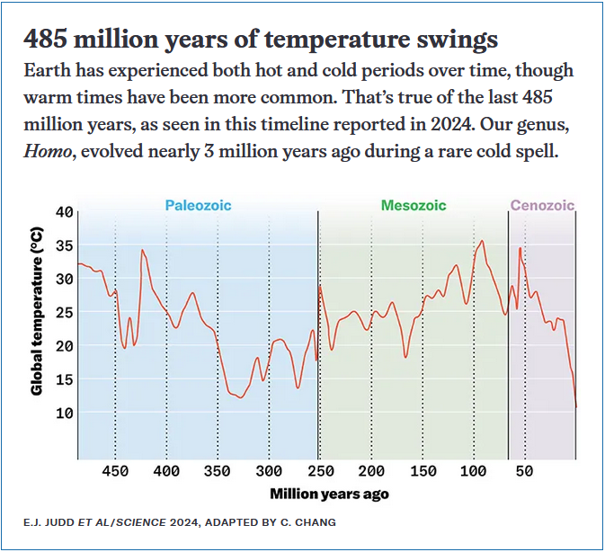

Graph Questions
1. Approximately how many years ago did the Mesozoic Era begin?

2. During which era depicted in the graph were the coolest temperatures recorded?
- Paleozoic
- Mesozoic
- Cenozoic

3. Which era always remained 15 degrees Celsius (or hotter)?
- Paleozoic
- Mesozoic
- Cenozoic

