Student Worksheet: Catchy catalysts and exciting enzymes
Directions: Read the Science News article “Carnivorous plants eat faster with a fungal friend” and answer the first set of questions on your own. Discuss and answer the second set of questions with a partner. For the third section, work with your partner to find another example of an enzyme or catalyst. Then answer the questions about your example on the class sheet before discussing the final question with your class.

Carnivorous plant and fungal enzymes
1. What is the purpose of the enzyme produced by the leaves of a sundew plant?

2. What happens to the rate of insect decomposition when the fungus called Acrodontium crateriforme (A. crateriforme) is present? Explain your answer using data from the article.

3. Draw a graph to show how the amount of ant powder on a leaf of a sundew plant changes over time. Then draw another graph to show how the presence of A. crateriforme impacts the same amount of ant powder on a sundew plant leaf over the same timeframe as that in your first graph. Explain how these graphs compare and any other information you might need.

Enzymes to catalysts
1. How would you define an enzyme from the examples given in the article?

2. Read this short article that contains the definition of an enzyme. What do you need to add to your definition of an enzyme? Are enzymes consumed as a part of a reaction? How do enzymes serve their purpose on a molecular level?

3. Compare catalysts to enzymes. How do they relate to each other?

4. In the Science News article “New, greener catalysts are built for speed,” the author uses many metaphors to describe catalysts and what they do. One example is: “It’s an excellent catalyst, able to turn standoffish molecules into fast friends.” Come up with your own metaphor to describe a catalyst or enzyme.

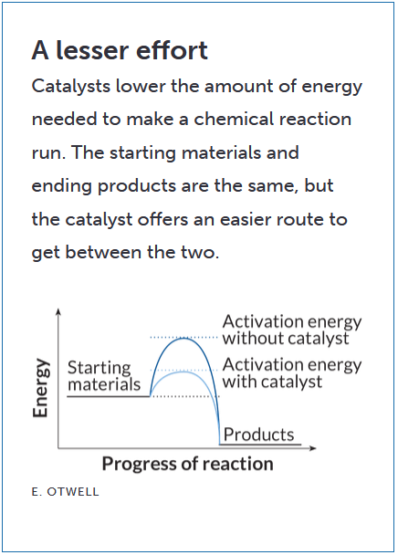
5. Use the potential energy diagram, right, to explain how a catalyst impacts activation energy, or the minimum amount of energy that molecules must have to start a particular reaction. On the y-axis, with a vertical line, label the overall energy for both the catalyzed and uncatalyzed reaction curves. What do you notice about this amount of energy? Why does this make sense?

Catchy catalysts and exciting enzymes
1. Now it’s your turn to find another example of an enzyme and catalyst in the Science News or Science News Explores archive. In a shared sheet and according to your teacher’s directions, provide the link to the article you found, name your catalyst (or organism that produces the enzyme), say whether it is an enzyme or not, explain what chemical reaction it catalyzes, and say why it interests scientists.

2. As a class, discuss why scientists are generally interested in learning more about enzymes and other catalysts. What are some practical applications of the examples found by your class?

