Student Worksheet: Smartphone Behavior
Directions: Smartphone use is changing human behavior and likely influencing our brains. New research is turning up clues as to how our interaction with devices is shaping our memory, navigation and even our happiness. Use the data visualization “Screentime” and graph “What am I missing” to analyze data on phone use and behavior. Read the short summary, graph titles and captions before completing the questions below.
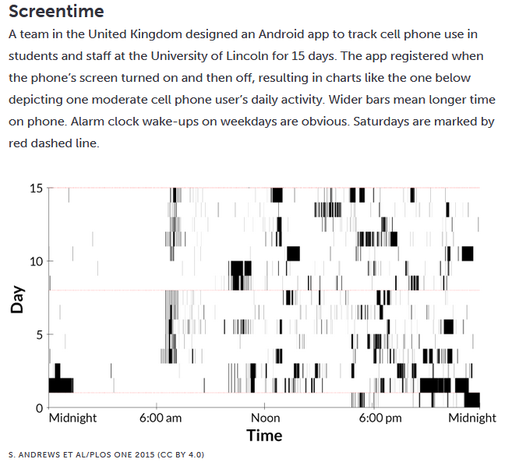
S. Andrews et al/PLOS ONE 2015 (CC BY 4.0)
Graph Questions
1. At what time of the day did this individual most use their cell phone?

- 6:00am-12:00pm
- 12:00pm-6:00pm
- 6:00pm-12:00am
- 12:00am-6:00am

2. Why do you think more people reported checking their phones between 6:00 pm- 12:00 am?

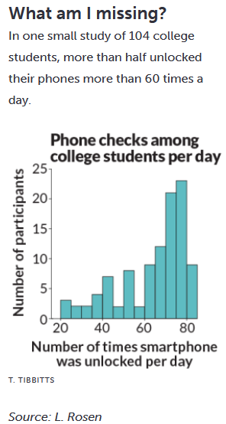
T. Tibbitts, Source: L. Rosen

3. What percentage of participants unlocked their phone more than 60 times a day?

