Teacher Template: Technically Fiction
Use this lesson plan to learn about an article type called Technically Fiction that is published by Science News Explores in print and online. You can also access a lesson plan template that can be used with any Technically Fiction article. Note that all print Technically Fiction articles are also online, where they contain multimedia resources and Power Words (relevant vocabulary words) and are longer in length.

What is a Technically Fiction article?
Each Technically Fiction article focuses on a fictional phenomenon and explains the science behind what it would take to make it reality and whether it could even be possible. Articles vary in length but generally include 2-3 main sections and sometimes have videos embedded in them.

How can you use Technically Fiction articles in the classroom?
Technically Fiction articles can be used to engage students in science. By focusing on stories students may already be familiar with outside of school, these articles make science fun, relevant, and exciting for students. They can be used to connect to concepts you’re already covering in class, or for a homework assignment to get students excited about science reading.

What is a literacy practice that can be used with this type of article?
Concept maps are a helpful literacy practice to introduce to your students and can be useful with Technically Fiction articles. Step 3 below outlines how to pair a concept map with a Technically Fiction article assignment. Click here for an overview of the concept maps as a literacy practice.

Some example Technically Fiction articles include:
Star Wars’ cutest droids would get stuck on the beach
Harry Potter can apparate. Can you?
What makes Aquaman special? He can take a lot of pressure
Here’s why Rapunzel’s hair makes a great rope ladder
Frozen’s ice queen commands ice and snow – maybe we can too
Could we make vibranium?
How would a mermaid sound underwater?
Could we build a mecha?
Could Wednesday Addams really jolt a frog back to life?

Build your lesson plan based on a Technically Fiction article:
*Please note: the Technically Fiction article provided in the template below is published in the March 2025 print issue of Science News Explores and its online version is available here.

Step 1: Choose a Technically Fiction article that relates to a topic you teach

Browse the archive of Technically Fiction articles or open the latest print issue of Science News Explores to find a Technically Fiction article that highlights a topic you teach. To browse the online archive, go to the page where all Technically Fiction articles are posted by publication date and scroll through the stories

What article are you using? Paste the URL for the online version below.

What is the main topic, concept or phenomena you want your students to take away? *Tip: Use the Power Words at the end of the online article to identify related topics that you may not have thought about initially.

What are a couple of related topics that you want students to understand?

How is this topic relevant to student experiences/interests?

Step 2: Engage students with the Technically Fiction topic

Technically Fiction articles focus on a fictional phenomenon from pop culture (TV shows, movies, books, etc.). Many articles include a video or image that relates to the fictional phenomenon. Either use the multimedia resources provided in the article or find a clip or excerpt that highlights the fictional phenomenon. Show it to your students at the beginning of class to hook their interest. Ask them to write questions they have about what they saw, then use the following prompts to have a class discussion about the viability of the fictional example:
Do they think it could exist in the real world? Why or why not? What would they want to investigate to determine its viability? Are there real examples that are like the fictional phenomenon? What scientific concepts can they think of that are related to the fictional example?

Step 3: Have students read the article using a literacy practice

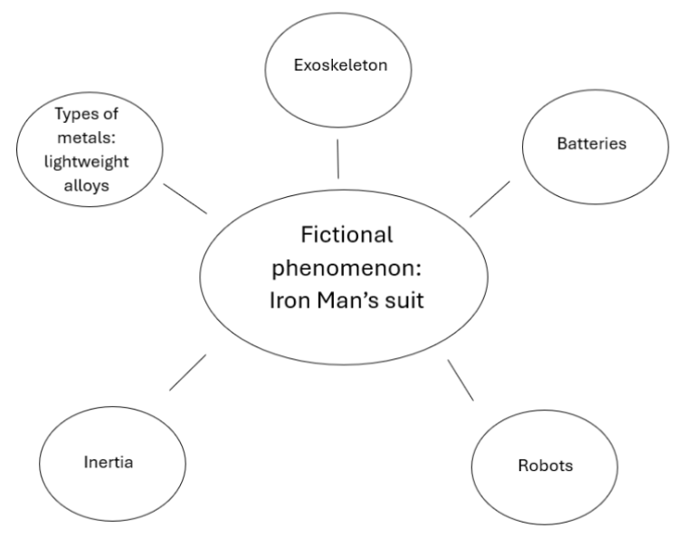
Teach students a literacy practice, such as concept maps. Then, have them read either the print or online Technically Fiction article while using the literacy practice. Concept maps are visual organizers that have students make connections between concepts to build their understanding. Two concept maps could be created with the Technically Fiction article. You can choose to require both or only one. The examples below are for the Technically Fiction article, “Move over Iron Man, exoskeletons are getting real.”

The first concept map focuses on connecting the fictional phenomenon from the Technically Fiction article with scientific concepts that students are familiar with. Students should identify the features of the Technically Fiction example and organize their concept map around them. Students should connect those potentially fictional features with real-world scientific concepts.

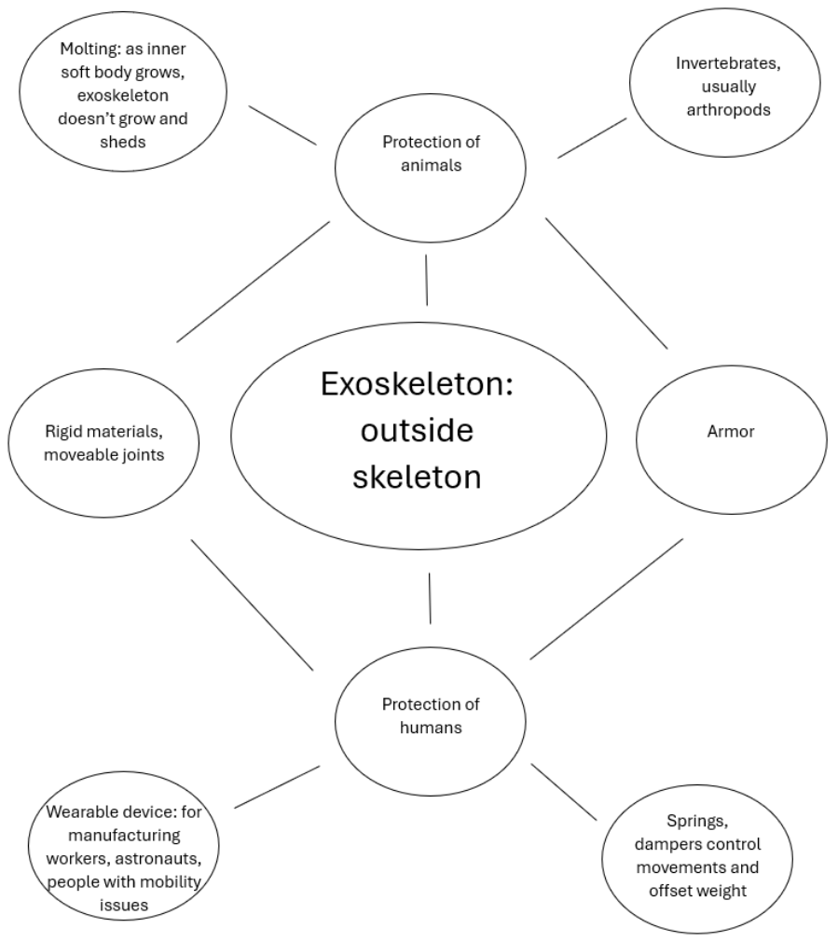
The second concept map builds students’ understanding of the real-world scientific concepts that are highlighted in the Technically Fiction article. For the second concept map, students should build on at least one of the concepts highlighted in the article with related concepts and details. Further research may be needed to make connections between the main concept from the Technically Fiction article to other related concepts. Students can search the Science News or Science News Explores archives for a recent news story or science research application that applies to this concept.

Have students share and compare their concept maps with a partner.

Step 4: Have students extend their knowledge to another example

If class time allows, or for homework, have students complete one of the application steps below. Choose whichever option works best for your classroom or allow students to choose their own. Grade the homework assignments or have students share their examples during the next class period.

Option 1: Make connections
Ask students to connect the same concepts covered in your chosen Technically Fiction article to other real-world applications. Beyond what is mentioned in the article, are there other uses or inventions that involve the concept that could be beneficial? Students can search the Science News or Science News Explores archives for a recent news story or science research application that applies to this concept. Ask students to be creative and write a paragraph that explains what they come up with. For example, students could research ways a hard exoskeleton could offer protection to any softer objects, potentially touching on biomimicry and engineering principles.

Option 2: Create your own Technically Fiction article
Ask students to find their own example of a fictional phenomenon that they’re interested in and write their own Technically Fiction article about it. Have students follow the same steps as the Technically Fiction article or the first concept map to highlight the scientific concepts that apply to the fictional phenomenon and discuss whether it could exist in real life. For example, a student could choose to focus on Harry Potter’s invisibility cloak as their fictional phenomenon and create a concept map like the one below.

Option 3: Invention Activity- Catalog Combo
This activity is specifically suitable for Technically Fiction articles that feature an invention. Ask students to choose a random object in the room or from a bag of random objects that you have selected. Have students brainstorm new inventions that they could create by combining that object with the invention featured in the Technically Fiction article. For example, they could combine the material, function, or shape from the classroom object with the Technically Fiction invention, such as using the wood from a pencil combined with the transformation ability of a mecha robot to create tables that transform into shelves or applying the function of a water bottle to the ice tower technology to create an icy bottle that keeps beverages cold. If time allows, have students create a catalog entry for their invention that advertises its form, function and cost. Students can use this template to plan their invention.

