Student Worksheet: Uncovering the ancestry of the marsupial mole
Directions: An animal’s evolutionary history can be challenging to understand when many of its ancestral species may no longer be living and are therefore unfamiliar to us. In this lesson, you will perform a series of tasks to get a better understanding of how phylogenetic trees and cladograms are assembled and what the branches mean. You will begin by reviewing new findings about the classification of the marsupial mole provided in the Science News article “Mole or marsupial? This subterranean critter with a backward pouch is both.” Then, your teacher will ask you to analyze provided examples of a phylogenetic tree and a cladogram so you can see how these diagrams work. Finally, you will explore the different taxonomic categories associated with the marsupial mole.

Mole or marsupial?
1. The marsupial mole has remained elusive and has challenged scientists to correctly classify its ancestry. Name two obstacles that have prevented scientists from understanding these animals better.

2. Underground life poses many challenges. The article mentioned that the marsupial mole has a backward facing pouch. What reason do they speculate for the pouch to be positioned this way?

3. How does the extra hemoglobin gene help marsupial moles survive underground life?

4. Hypothesize why these organisms do not have external ears or working eyes. Be sure to address both structures in your answer.

Phylogenetic trees vs. cladograms — what’s the difference?
Using the example phylogenetic tree below, answer the following questions as instructed by your teacher.
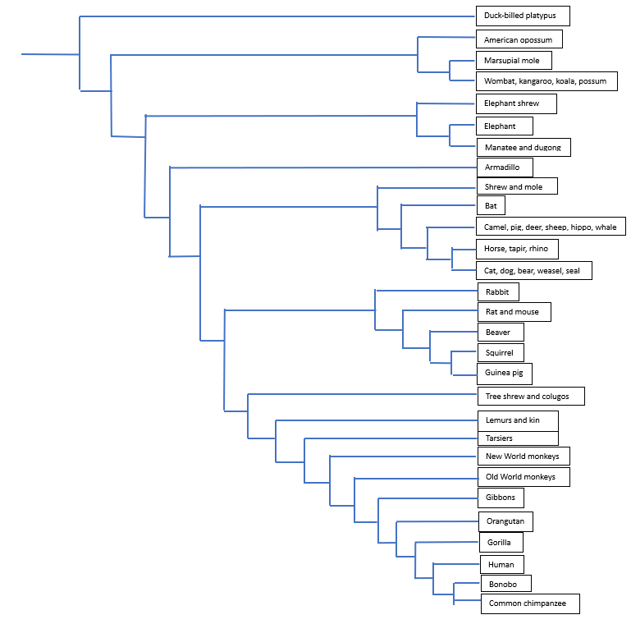
1. What animal is most closely related to a Common chimpanzee?

2. What 4 animals are most closely related to the marsupial mole?

3. What two animals are the least closely related to each other according to the phylogenetic tree?
4. Which animal pair below shares an ancestor that is more recent than any other pair?
- Squirrel and rabbit
- New World monkeys and rabbits
- Gibbons and bat
- Elephant and armadillo

Use the following cladogram that traces characteristics shared by sharks, ray-finned fish, crocodiles, birds, primates and rabbits to answer the questions below as instructed by your teacher.
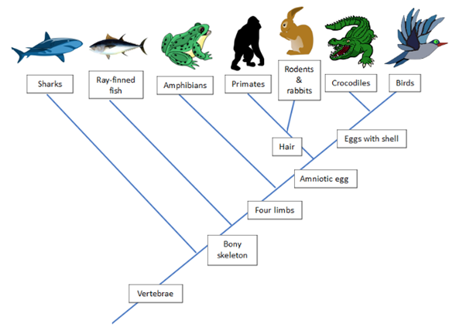
1. What two derived, or common, characteristics do sharks and ray-finned fish share according to the cladogram?

2. What characteristic separates the crocodiles and birds from all other organisms represented in the cladogram?

3. What derived characteristics do primates and rabbits share? List all 5.

4. What is the closest relative of rodents & rabbits on this cladogram?

Evolutionary history of the marsupial mole
Research time! In order to understand the evolutionary history of the marsupial mole, you will be investigating the taxonomic groups illustrated in the evolutionary diagram of the marsupial mole (Figure 2 in the article). This diagram illustrates genetic similarity based on the number of certain commonalities (indicated by the red dots in Figure 2) between species.
Be prepared to share your research with the class as instructed by your teacher.

1. Based on the diagram, which two groups are the most similar? Explain your answer.

2. Based on the diagram, which two groups are the least similar? Explain your answer.

3. In your group, choose one of the taxonomic groups below. Find 3 major characteristics for the group and identify at least two animals that fit the category.

Dasyuromorphia
Peramelemorphia
Notoryctemorphia
Diprotodontia

