Student Worksheet: Cosmic Collision: A Far-Flung Possibility
Directions: Explore the Scale of the Universe animation, then answer the “Before Reading” questions. Then read the online Science News Explores article “A passing star could fling Earth out of orbit — or into the sun” and answer the following questions as directed by your teacher.

Before Reading
1. Explore the Scale of the Universe animation. Give an example of something so small that it can’t be measured in a way that can be confirmed.

2. Give an example of a space object similar in length to the state of Texas.

3. Give one example of a virtual world that is longer than the diameter of Neptune.

During Reading
1. How were computer models used in this study?

2. Give one example of a variable — or factor that was accounted for — by the computer model.

3. What is the chance of an apocalypse on Earth caused by a passing star? Is this a likely scenario? Explain.

4. Which planet has the greatest potential to warp the orbits of other planets?

5. Renu Malhotra speculates that passing stars might long ago have influenced the orbits of the three giant planets in our solar system. Give one observation that supports his theory.

6. A star moving slowly relative to the sun poses a greater risk of distorting planetary orbits than a star that passes by more quickly. Explain why.

7. Contrast Pluto’s risk of a catastrophic orbital change over the next 5 billion years with that of Earth’s chance of such an orbital change.

After Reading
1. In a cause-and-effect relationship, one event (the cause) brings about a second event (the effect). Write out one possible series of steps that could lead from the starting event (a passing star) to the final event (a catastrophe on Earth). You should include at least five events in your cause-and-effect linkage chain. Use details from the article in your answer.

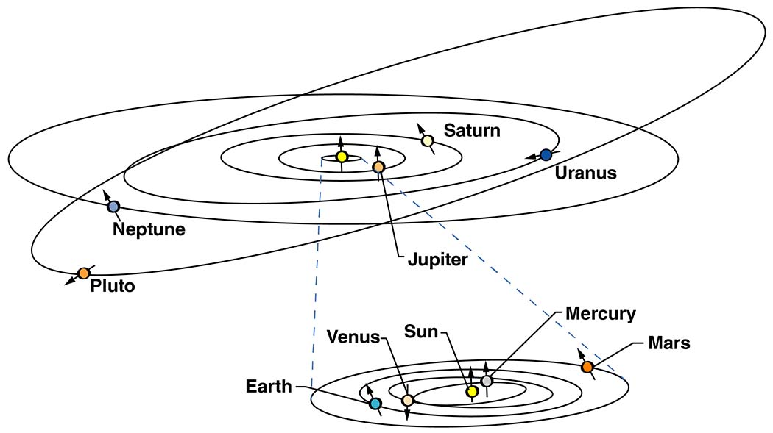
NASA
2. Examine the image above depicting planets and other objects in our solar system. The circles show each object's orbital path around the sun. Arrows show the object's axis. Note how most planets orbit within the same plane. That means their orbits form a flattish disk. However, there is one exception to this pattern. Compared to the planets, Pluto's orbital path appears tilted. Based on what you've read in this article, come up with one theory to explain Pluto's tilted orbit. Refer to the information mentioned in this story that inspired your theory.

