Student Worksheet: Astronauts Need Oxygen
Directions: In this activity, you will wonder about electrolysis, chemical reactions and how technology is used to help astronauts. Your teacher will assign reading and the first set of questions for homework. Following a class discussion and demonstration on electrolysis, you and your classmates will break into groups to wonder about what is happening at the particulate level during electrolysis. Your group will then discuss the validity of different models and apply the models to the broader situation of what is happening without buoyancy.

Observing electrolysis
Read the Science News article “Astronauts need oxygen. Magnets could help” for homework and answer the first four questions before class.

1. What is electrolysis?

2. List one qualitative observation from the video included in the article, providing a detailed description along with your interpretation of its significance or underlying meaning.

3. List one quantitative observation from the video that includes a number or measurement.

4. Brainstorm and write two questions that you are wondering about after reading the article.

Developing a model of electrolysis
With a partner, answer the following questions and create images that best describe your present thoughts and ideas about the situations listed below. Please be creative and adventurous with your ideas.

1. Draw a model of the physical change of water (H₂O) from a liquid to a gas after energy is added. Your model must have:
- Symbol for H₂O: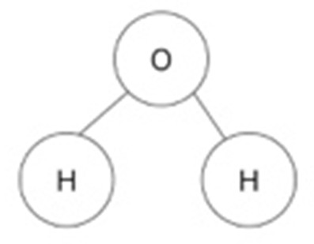
- At least five water molecules in each box
- Symbol for energy: E

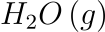 |  | 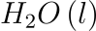

2. Using your model from above as evidence, explain whether the way the atoms are connected to each other changes when transitioning from the liquid phase to the gas phase.

In the Science News article “Astronauts need oxygen. Magnets could help” scientists applied electricity to liquid water, which caused a chemical reaction:

In the image below is a simplified diagram of the electrolysis of water. The bubbles produced are hydrogen and oxygen gas.
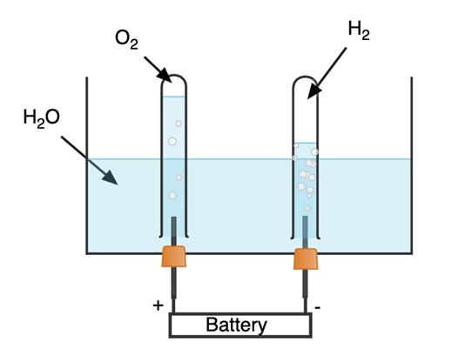

3. Based on the above diagram of electrolysis and the chemical change, draw a before, during, and after model of the atoms/molecules and energy involved in the chemical change. Your model must have:
- Symbol for H₂O:
- Four water molecules
- Symbol for energy: E
- Symbol for Hydrogen (H₂): H-H
- Symbol for Oxygen (O₂): O=O

Before | During | After
4. Based on your model above, analyze and explain where the oxygen gas comes from during the chemical reaction.

5. What causes the water to “break” into hydrogen and oxygen during the electrolysis reaction?

Electrolysis in space
In the video in the Science News article “Astronauts need oxygen. Magnets could help,” bubbles of oxygen and hydrogen stream off electrodes toward magnets in an experiment performed in freefall at the Bremen Drop Tower in Germany.

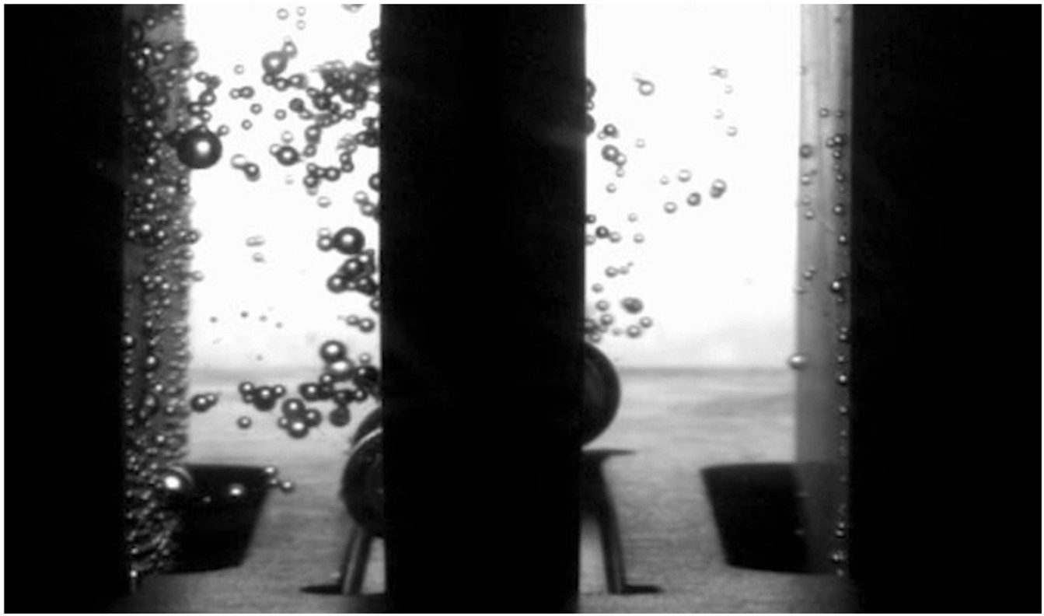

1. Label one bubble on the left as hydrogen gas (H₂) and one bubble on the right as oxygen gas (O₂) in the screenshot from the video above.

2. Add a force arrow to the labeled bubbles to show the pull of the magnetic field on the bubbles filled with hydrogen and oxygen gas.

3. Where do the oxygen and hydrogen gases come from in the image above?

4. Describe the direction in which the gas bubbles are moving. Why are they moving in that way?

5. Respiration is a chemical reaction that is happening in your body right now.

Using your models as evidence, explain why electrolysis (and the new finding of using magnets) is important for astronauts.

