Student Worksheet: U.S. Dementia Cases on the Rise
Directions: Scientists predict that, by 2060, one million U.S. adults per year will develop dementia. The new estimate surpasses previous estimates of how many people will struggle with memory, reasoning and language difficulties that interfere with life.
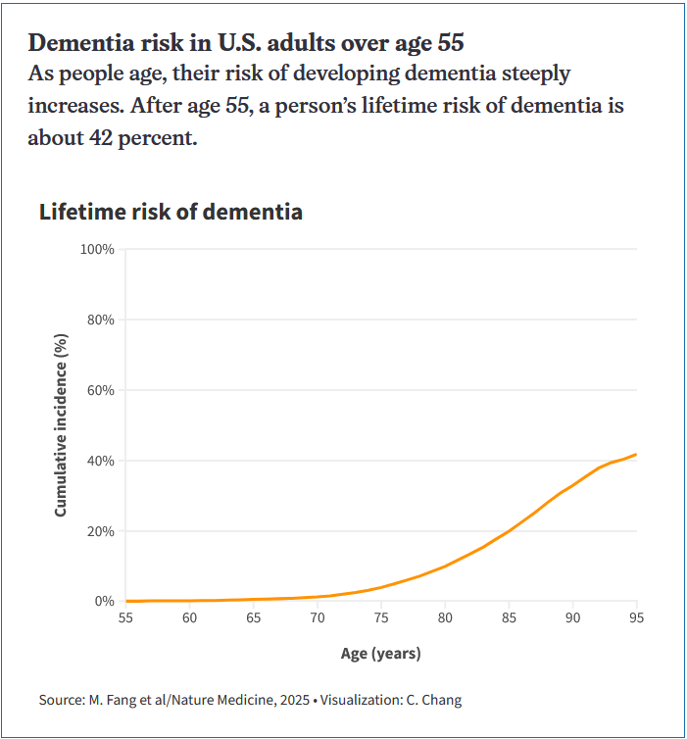
Graph Questions
1. At what age does the cumulative incidence (%) reach 20%?
- 65
- 70
- 85
- 90

2. According to the graph, what is the cumulative incidence (%) at age 95?
- between 10% and 20%
- between 20% and 30%
- between 30% and 40%
- between 40% and 50%
- between 50% and 60%
3. The y-axis of the graph tracks the cumulative incidence percentage. Cumulative incidence refers to the probability of developing a disease at a given time. What is the difference between the likelihood of developing dementia at age 80 versus age 90?

4. According to a study, people who received hearing aids experienced a lower rate of cognitive decline than those that didn’t. Why do you think being able to hear family members might contribute to warding off dementia?

