Student Worksheet: The rise of male contraceptive options
Directions: Contraceptive pills for women emerged in 1960, followed by hormonal implants, patches, vaginal rings and IUDs. But no new contraceptive methods have become available for men. New research could change that in the next five to 10 years.
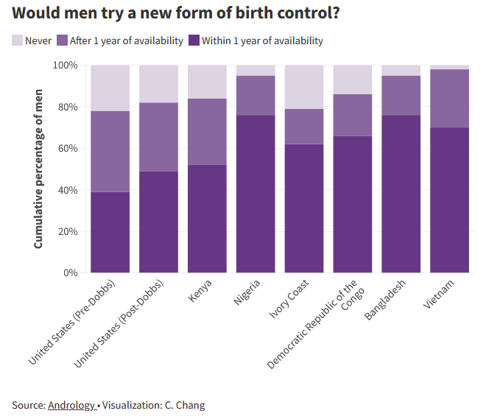
Graph Questions
1. Which country has the highest percentage of men willing to try male birth control within one year of availability?
- United States
- Nigeria
- Kenya
- Vietnam

2. Which country has the highest percentage of men not willing to try male birth control, no matter the timeline of availability?
- United States (Pre-Dobbs)
- Nigeria
- Kenya
- Vietnam

3. What is the approximate percentage of men in Vietnam willing to try a new form of birth control?

4. What is the approximate percentage of men in Vietnam willing to try a new form of birth after one year of availability?

