Student Worksheet: Mapping the Mississippi
Directions: Freshwater fish make vast treks, but their migrations remain hidden beneath the surfaces of rivers. This invisibility has left freshwater fish largely overlooked, even as their populations worldwide have plummeted. Now, global “swimways” for migratory fish are emerging as an important conservation focus.
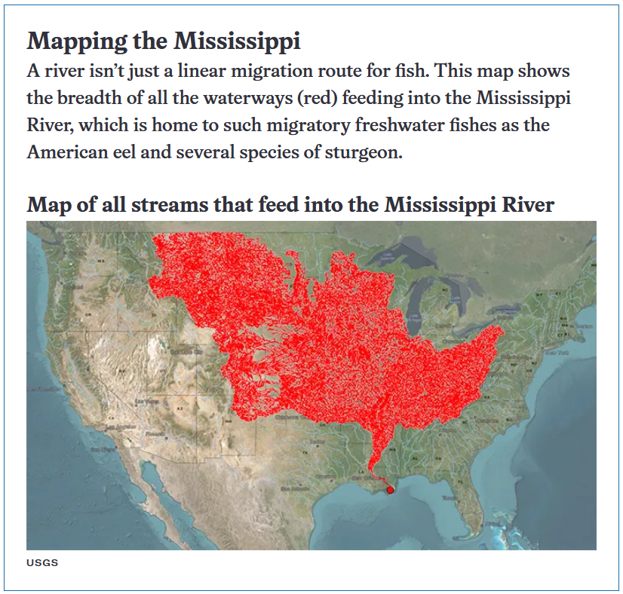

Graph Questions
1. In the map above, the waterways that feed into the Mississippi River are highlighted in red. Name at least 5 states that house part of this aquatic system.

2. The United States has two major mountain ranges, the Rocky Mountains and the Appalachian Mountains. How do these mountains interact with the waterways on the map?

3. How might pollution that gets dumped into the Mississippi River impact saltwater species found in the ​​Gulf of Mexico?

4. Why would a migratory fish be more impacted by damage to its ecosystem than a migratory bird?

