Student Worksheet: Take a hike
Directions: Walking just 7,000 steps per day can lower a person’s risk of certain health issues, according to a new study. Even a small increase in steps per day lowered health risks.
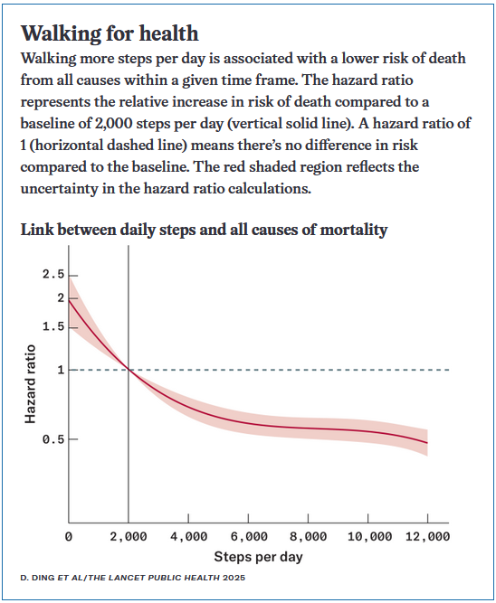

Graph Questions
1. What measure is used for steps per day to represent a baseline for comparison?
- 2,000 steps
- 4,000 steps
- 6,000 steps
- 8,000 steps

2. Taking how many steps per day has the highest hazard ratio, indicating poorer health and greater risk of mortality?

3. Based on the data in the graph, why do you think health experts may have lowered the recommended number of steps per day from 10,000 to 7,000? Explain.

4. Do you currently count your steps or daily activity in any way? If so, what do you do with the data you collect? Does it inform your daily routine in any way? If not, would you like to count your daily steps if you are able to in the future?

