Student Worksheet: Wiring the mind
Directions: Researchers are drawing inspiration from the brains of creatures from worms to humans to develop more efficient, more capable forms of AI.
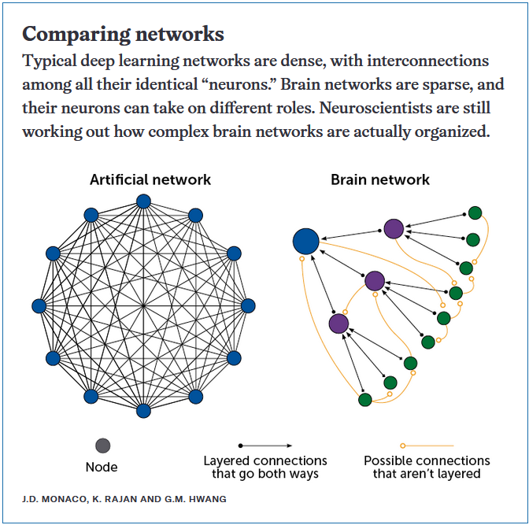

Graph Questions
1. According to the diagram above, what do the black lines in the Brain network represent?
- node
- layered connections that go both ways
- possible connections that aren’t layered

2. Describe at least two differences between an artificial network and a brain network. Be sure to include information about nodes as well as connections.

3. Why do you think scientists are comparing artificial networks with brain networks?

4. As technology improves and people become more familiar with AI, more aspects of our daily lives could be influenced by artificial intelligence. Name at least one benefit and one drawback of AI becoming part of our routine.

