Student Worksheet: Cancer patterns in younger generations
Directions: Cancer is typically a disease of older people. But since the 1990s, rates of early onset cancer have been rapidly increasing globally.
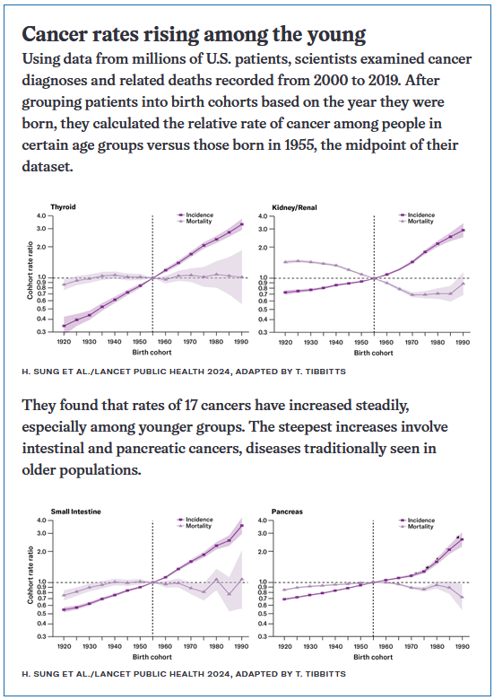
Graph Questions
1. Of the different cancers analyzed, which two types of cancer show the steepest rate of increase among younger groups?
- pancreatic and renal
- pancreatic and intestinal
- intestinal and thyroid
- intestinal and renal

2. Of the different types of cancer studied, which shows the steepest decline in mortality?
- thyroid
- kidney/renal
- small intestine (intestinal)
- pancreatic

3. Between 1970 and 1990, which type of cancer exhibited both an increase and a decrease (and is now increasing again) in mortality?
- thyroid
- kidney/renal
- small intestine (intestinal)
- pancreatic

4. Why do you think the answer to #3 has decreased and then increased again?

