Student Worksheet: Eyes are not all equal
Directions: Golden apple snails can completely regrow a functional eye within months of having lost one. Understanding how the snails re-create or repair their eyes might someday lead to therapies to heal people’s eye injuries or reverse some eye diseases.
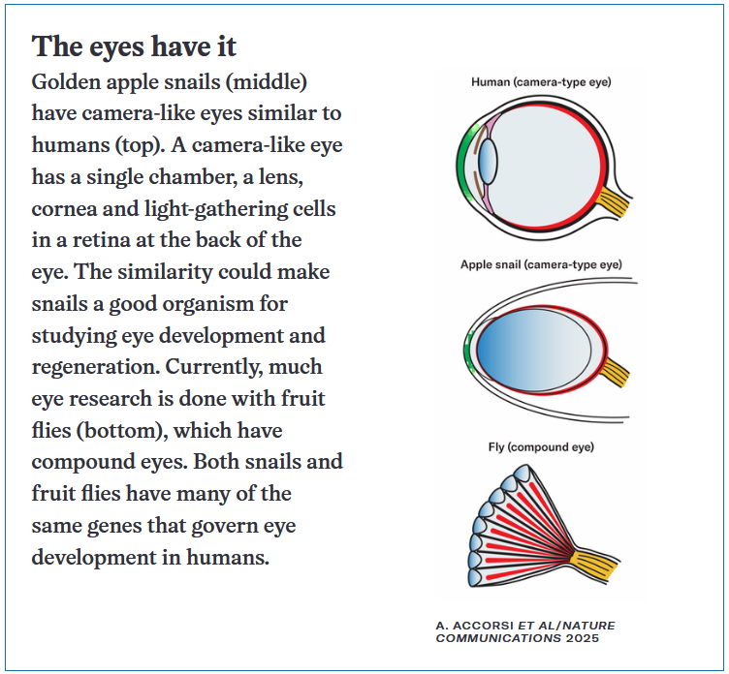

Graph Questions
1. Of the three eyes pictured above, which eye appears to be the most different from the others?
- Human eye
- Apple snail eye
- Fruit fly eye

2. True/False: A camera-like eye has a double chamber, a lens, a cornea and light-gathering cells in a retina at the back of the eye.

3. Why do you think fruit flies have been a model organism for studying eye disorders/diseases? Provide at least 2 reasons.

