Student Worksheet: Are cutbacks cutting our future?
Directions: In 2025, the Trump administration froze or terminated more than 3,800 research grants from the National Institutes of Health and the National Science Foundation. The roughly $3 billion in cuts targeted initiatives related to diversity, equity and inclusion; environmental protection; vaccine hesitancy; public health and more.
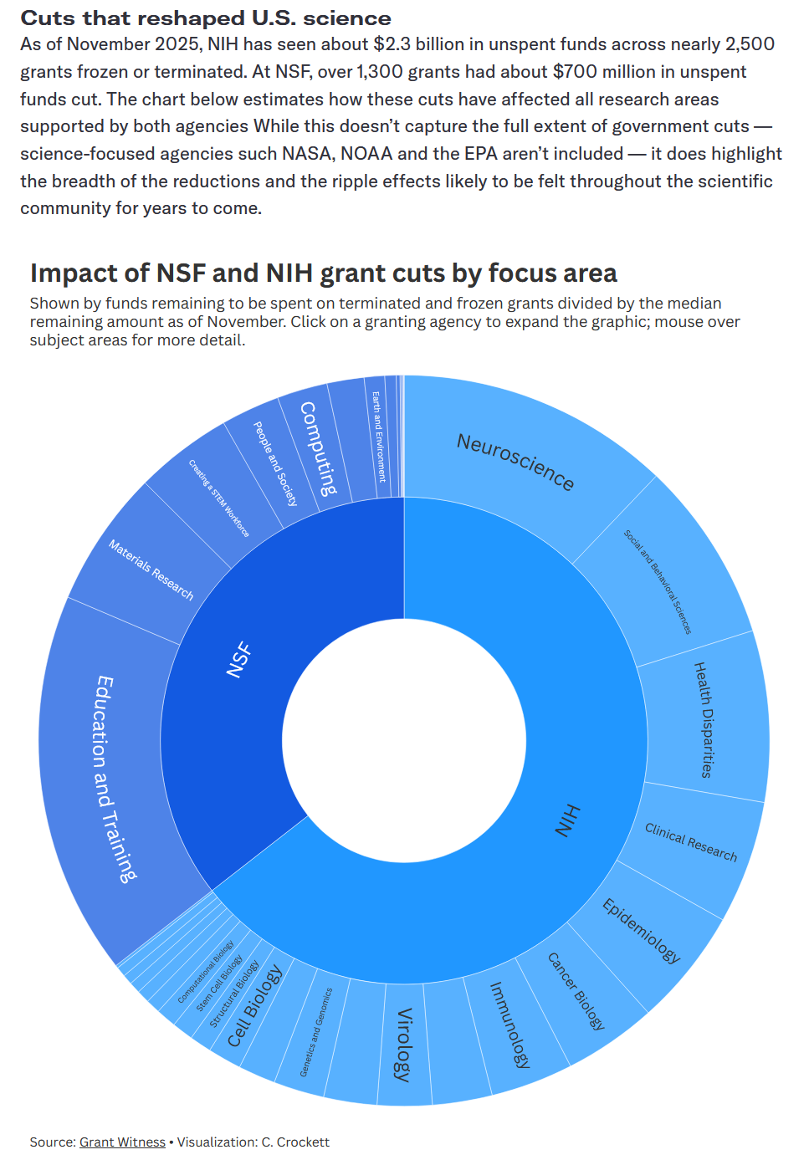
Graph Questions
1. Which organization has had more money cut from its funding, NIH or NSF?

2. For NSF budget cuts, what is the largest category of budget cuts?

3. Many research topics have been affected by budget cuts. Choose the answer below that correctly orders the topics from least affected to most affected.
- epidemiology, cell biology, health disparities, neuroscience
- neuroscience, health disparities, epidemiology, cell biology
- cell biology, epidemiology, health disparities, neuroscience
- health disparities, cell biology, epidemiology, neuroscience

4. What impact do you think cutbacks to scientific research will have on future medicine and technology? Be sure to include at least two examples of issues.

