Student Worksheet: Mapping emotions in the body
Directions: For 3,000 years, humans have connected emotions to some of the same body parts. An analysis of clay tablets reveals that ancient Mesopotamians felt love in the heart and fear in the gut, as we do today.
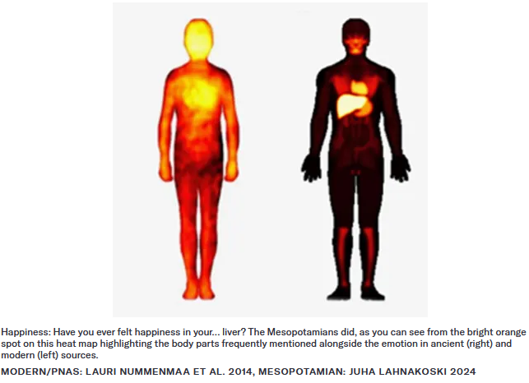

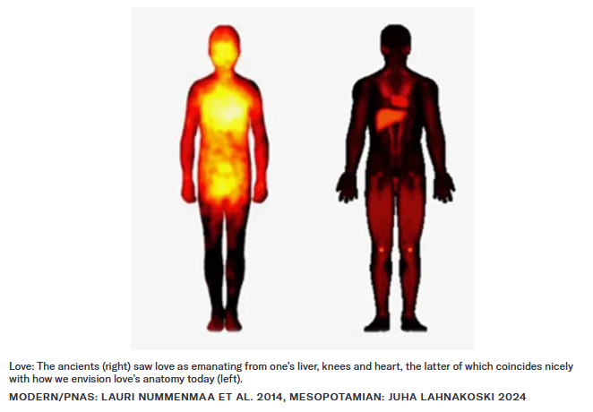

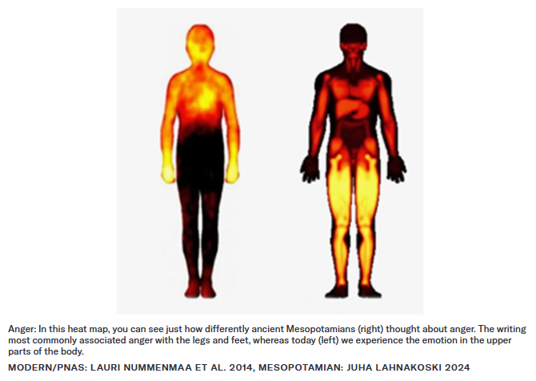

Graph Questions
1. Ancient Mesopotamians saw love as being tied to the liver, knees and heart. Which of these areas coincides with the current idea of love?

2. Compare and contrast the parts of the body highlighted in the maps for anger and describe why you think those body parts are associated with anger today.

3. What parts of the body are consistently associated with all three models that reflect how we envision emotions today? Name at least two and explain why you think these are highlighted.

