Student Worksheet: Balancing the protein puzzle
Directions: Protein is having a moment. It’s cropping up as an additive in all sorts of foods, and social media influencers tout high-protein diets as key to big muscles. But people in the United States typically get enough protein; they just might not be getting the right mix.
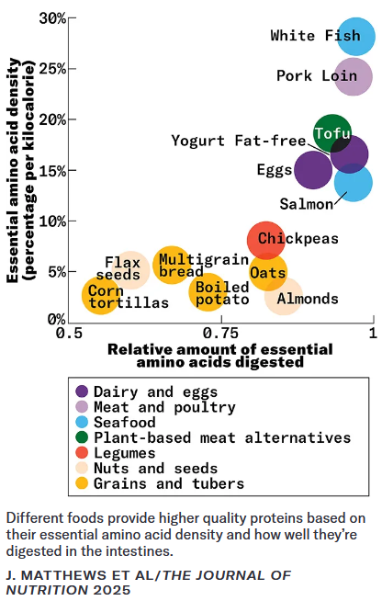

Graph Questions
1. According to the graph, which type of foods have the least amount of essential amino acid density (percentage per kilocalorie)?

a. dairy and eggs
b. seafood
c. legumes
d. grains and tubers

2. Which foods on the graph have the lowest percentage per kilocalorie of essential amino acids?

3. Which food has 25% of essential amino acid density per kilocalorie?

4. Read the caption. What does the quality of protein in food depend on? Given this information, which food would you choose to eat to get the highest quality protein?

