Student Worksheet: Needle-free insulin
Directions: In this activity, you will explore how applications of chemistry could help patients with diabetes. First, answer the “How medicine gets in your body” question set, which will require your creativity and brainstorming. Then, read the Science News article “In animal tests, this needle-free insulin acted as fast as injections” and answer questions about the reading. Finally, apply your knowledge of science and information from the reading to complete the “Modeling Biological and Chemical Interactions” section.

How medicine gets in your body
Before reading the Science News article “In animal tests, this needle-free insulin acted as fast as injections,” work with a partner to complete the following questions.

1. Brainstorming, list the facts that you know about how medicine is administered.

2. What are some of the difficulties of administering medicines? Think about what you feel or notice when you receive an injection and how injection compares with other ways of administering medicine.

3. Based on your ideas and experience, write a possible scientific question about administering medication.
Insulin injections
Read the Science News article “In animal tests, this needle-free insulin acted as fast as injections” and answer the following questions.

1. What is transdermal drug delivery?

2. Describe the innovative idea that scientists developed.

3. List regular insulin injection problems.

4. Compare and contrast the listed problems to your brainstorming in the first set of questions. Explain additional problems or components you did not consider.

5. Explain other techniques that researchers use to increase skin permeability.

6. What are the disadvantages of these techniques?

Modeling Biological and Chemical Interactions
The epidermis has several layers. Each layer has a different pH, which influences how molecules interact with compounds in the skin layers.

Layer of Epidermis | pH | Acidity | Polymer’s Charge
Stratum corneum | 4.5-5.5
Stratum granulosum | 6.8
Stratum spinosum | 7-7.4

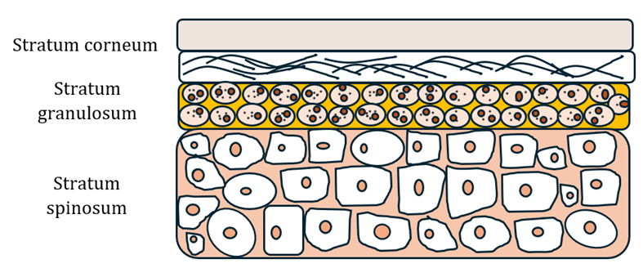

1. In the example in the article, the skin-penetrating polymer changes its charge as the pH of its environment changes. In the chart above, describe whether the environment is acidic, basic, or neutral in the “Acidity” column, based on the pH or pH range shown for each skin layer. Using information from the article, fill in the “Polymer’s Charge” column, indicating what charge the polymer would have based on the pH of the skin layer.

2. The outermost layer of skin, the Stratum corneum, contains negatively charged fatty acids. Draw a diagram that shows how the insulin polymer complex interacts with the fatty acids in the first layer of skin. Make sure your diagram indicates charges and describes why the interactions occur.

3. Draw a diagram that shows what happens to the insulin polymer complex as it gets close to entering the Stratum granulosum skin layer.

4. Using the following links, compare and contrast the size of insulin and nicotine.
- Nicotine
- Insulin

5. Based on your answers above, explain why nicotine may be more easily administered in a patch whereas insulin without the new technology cannot.

6. Using a metaphor for the polymer’s role, explain why the new technology described in the article worked.

7. List some of the factors that need to be considered when designing a drug to travel through the skin layers.

8. What happens to the polymer once the insulin polymer complex completely permeates the skin? What are possible implications of this?

9. What do you think the next steps of this research should be?

