Student Worksheet: Dark side of science and society
Directions: Sexual harassment of science students is widespread in the United States, according to a 2018 report by the National Academies of Science, Engineering and Medicine. To improve, universities need to change their culture and environment, and research and legislation could help guide their actions.
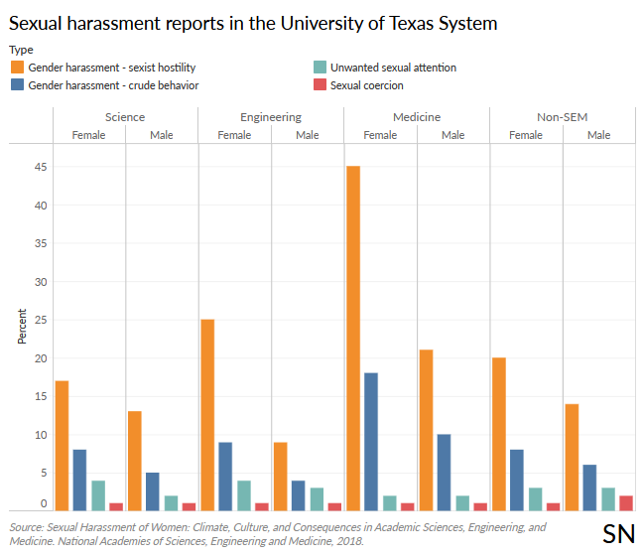

Graph Questions
1. Which type of sexual harassment was reported most frequently across all branches of the University of Texas system?
- gender harassment – sexist hostility
- gender harassment – crude behavior
- unwanted sexual attention
- sexual coercion

2. Which type of sexual harassment was reported least frequently across all branches of the University of Texas system?
- gender harassment – sexist hostility
- gender harassment – crude behavior
- unwanted sexual attention
- sexual coercion

3. Which gender and category had the highest rate of sexual harassment reports?
- females in science
- females in engineering
- females in medicine
- females in non-SEM

