Student Worksheet: Dorm room data: COVID-19 cases in 5 universities
Directions: Universities that opened their campuses in fall 2021, during the COVID-19 pandemic, faced an uncharted, months-long experiment in infection control. Science News looked at the measures five universities took. Each school cobbled together periodic testing with rules about masks and public gatherings.
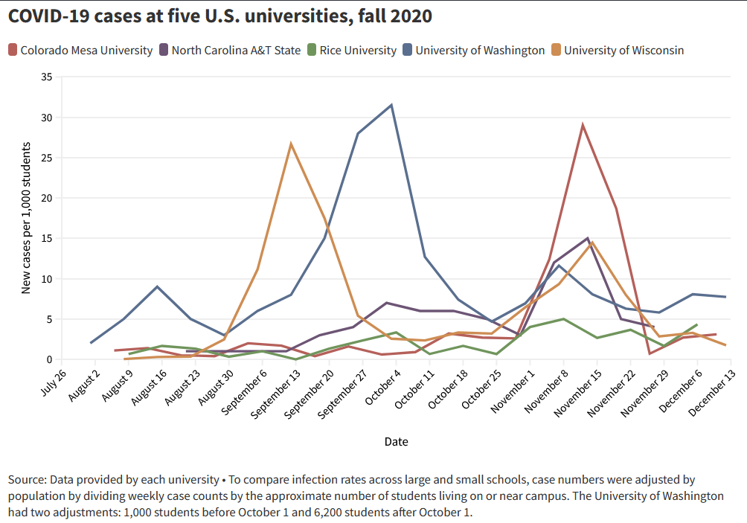

Graph Questions
1. According to the graph, when did all 5 universities involved in the study experience elevated cases of COVID?
- between August 30 and September 20
- between November 1 and November 15
- between October 18 and October 25
- between November 22 and November 29

2. What is the likely reason for the spike in COVID cases around the above time?

3. Which university experienced the biggest spike in COVID cases?
- University of Wisconsin
- Colorado Mesa University
- University of Washington
- North Carolina A&T State
- Rice University

4. Which university had the most consistent new cases of COVID-19 per 1,000 students in the fall of 2020? Support your answer by citing data.

5. Why do you think the researchers adjusted the case counts to the number per 1,000 students instead of just reporting total cases of COVID? In other words, if total cases of COVID had been reported, how would that information be misleading when comparing across the universities?

