Student Worksheet: A look at life’s origins
Directions: A group of single-celled microbes that belong to the domain of life known as archaea may have been crucial to the evolution of complex life. Members of this group, known as Asgard archaea, seem to have evolved in several ways that primed them to give rise to multicellular life. This suggests that complex life may evolve more easily than biologists have thought, but researchers are still working out how exactly it could have happened.
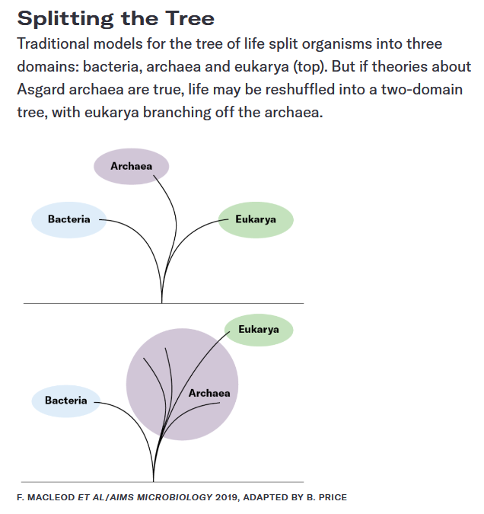

Graph Questions
1. Phylogenetic trees represent the history of an organism by showing evolutionary relationships among related organisms. Explain how the evolutionary history of Eukarya differs between the two diagrams.

2. What could the additional branches in the bottom diagram potentially indicate?

3. Prokaryotes are simple, single-celled organisms that do not have a membrane-bound nucleus. More complex cells, referred to as eukaryotes, have a membrane-bound nucleus. Which of the domains in the top diagram are likely not prokaryotes?

