Student Worksheet: Save our Sharks!
Directions: Many people fear sharks even though it’s more likely for someone to be struck by lightning than bitten by a shark. People should instead fear for sharks, many of which are threatened. Researchers are working to convince people that sharks, which are vital to maintaining the ocean’s health, are more valuable alive than dead.
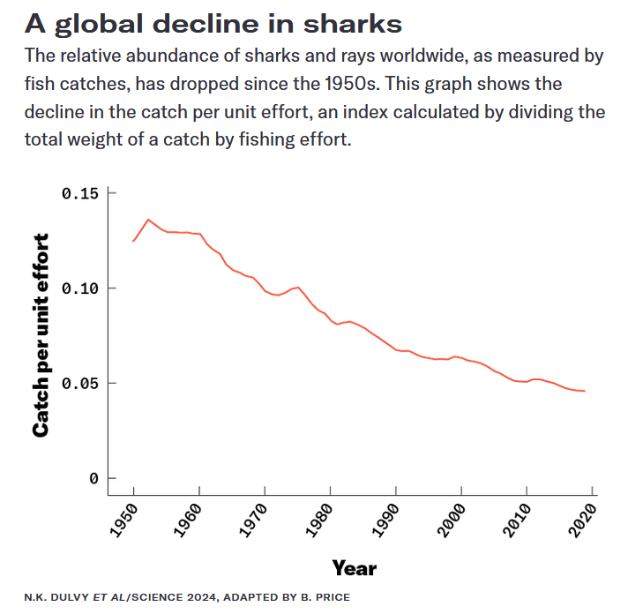

Graph Questions
1. Name what is being measured on the x- and y-axes in the graph.

2. Assuming that the same amount of effort was spent each year fishing, what does the graph’s trend indicate? Based on the title and caption, what assumption is being made from this trend by the scientist?

3. What is unclear to you from the graph?

4. According to the graph, in what year was the catch per unit effort the highest?
- 1950
- 1960
- 1970
- 1980

5. Sharks serve as a top predator in the ocean biome. What dangers exist for the overall health of the biome when a top predator is eliminated (or at least drastically reduced)?

