Student Worksheet: Cashing in on Carbon
Directions: Airlines often offer passengers the option to pay a few dollars for carbon credits that offset their share of the flight’s emissions. But those purchases might not be helping the climate because of problems with the voluntary carbon credit. Understanding how carbon credits work can help you decide what to do about your carbon footprint.
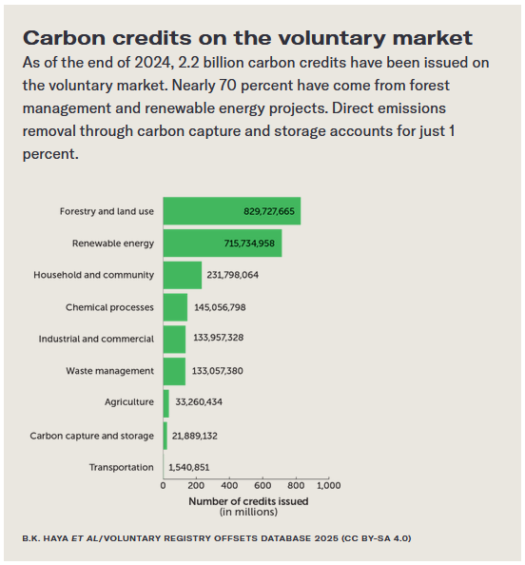
Have students read the short summary, graph title and caption before completing the questions below. Consider using an online survey tool, such as Padlet, Kahoot or Mentimeter, to provide students with instant feedback on their answers.

Graph Questions
1. Which categories have less than 130,000,000 credits issued? Select all that apply.
- renewable energy
- chemical processes
- carbon capture and storage
- transportation
- agriculture
- forestry and land use

2. What percent of credits come from household and community?
- About 5%
- About 10%
- About 15%
- About 20%
- About 25%

3. Think about your daily routine. How might you be able to reduce the amount of carbon that you release into the atmosphere?

4. Photosynthesis is a process that converts carbon dioxide and water into glucose and oxygen using energy from the sun. Which category/categories in the above graph would be directly impacted by the rate of photosynthesis? Why?

5. Why do you think that direct removal of carbon through carbon capture and storage accounts for just 1% of the available carbon credits?

