Student Worksheet: Compression of AI = Compassion for the Earth
Directions: Using AI gobbles up an enormous amount of energy, and the power needs of data centers may already be helping to drive up electricity costs in some areas. So researchers are looking to compress AI models to a more manageable size, which would also allow them to run on devices instead of online in the cloud. One approach uses a mathematical structure called a tensor network.
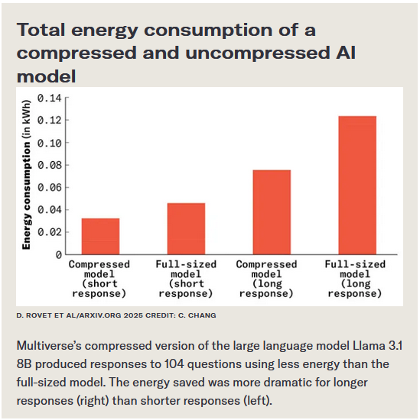
Graph Questions
1. According to the graph, which AI model used the least amount of energy?
- compressed model (short response)
- full-sized model (short response)
- compressed model (long response)
- full-sized model (long response)

2. According to the graph, which model used 0.08 kWh of energy?
- compressed model (short response)
- full-sized model (short response)
- compressed model (long response)
- full-sized model (long response)

3. The use of tensor networks enables the neural network in AI models such as ChatGPT to be compressed to a more manageable size. According to the graph, what is an advantage of compressing AI models using tensor networks? Explain using data from the graph.

4. Why do you think that researchers are exploring ways to improve efficiency in AI models?

