Student Worksheet: Food pyramid shuffle
Directions: The U.S. Department of Health and Human Services and the Department of Agriculture unveiled an overhauled food pyramid on January 7. It differs drastically from decades of previous recommendations. To learn about the new guidelines’ strengths and weaknesses, Science News spoke with Marion Nestle, a professor emerita of nutrition, food studies and public health at New York University.
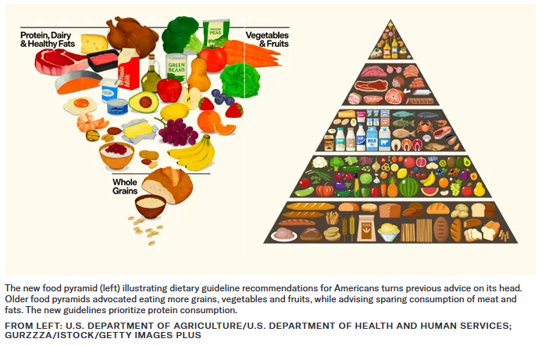
Graph Questions
1. Name a few differences you observe between the old and new food pyramids.

2. According to the diagram, which food group has remained relatively consistent in recommended consumption between the two pyramids?

3. In the article, Marion Nestle says that the guidelines include a strong recommendation to eat whole grains. Does this recommendation come across in the newly designed pyramid? Explain why or why not.

