Student Worksheet: Painful truth
Directions: In the United States, chronic pain affects tens of millions of people — about 1 in 5 adults. So researchers are on a quest to find new pain treatments that aren’t as addictive as opioids, a therapy that has fueled an epidemic that kills tens of thousands of people each year.

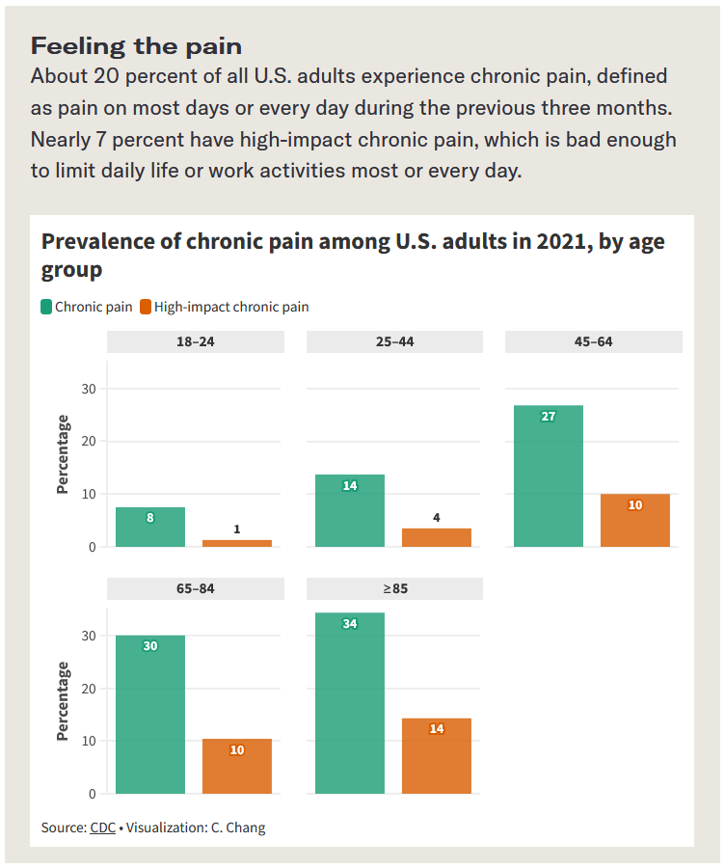
Graph Questions
1. Which age group reports the highest prevalence of chronic pain among U.S. adults in 2021?
- 18-24
- 25-44
- 45-64
- 65-84
- over 85

2. Which age group reports the lowest prevalence of high-impact chronic pain among U.S. adults in 2021?
- 18-24
- 25-44
- 45-64
- 65-84
- over 85

3. Does the graph indicate how many participants were included in this study? Why is that information important? Explain.

4. What is the source of the data in the graph? In your opinion, what could be difficult about collecting data from people that report pain levels?

