Student Worksheet: Understanding UFO sightings
Directions: Since UFOs entered the spotlight in United States in the late 1940s, they’ve come to be dismissed as a hoax or irrational obsession and thus unworthy of study by scientists. But government agencies and officials are trying to change that attitude so that more pilots or citizens will report unusual phenomena that may deserve scientific scrutiny or present a threat in U.S. air space.

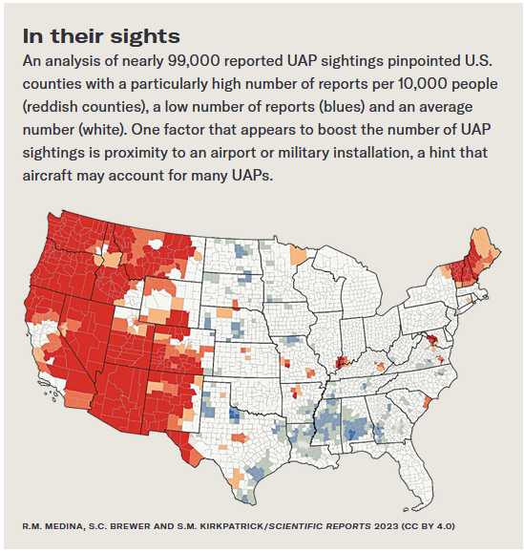
Graph Questions
1. In what part of the United States do the highest reports of UAP (unidentified anomalous phenomena) sightings occur?
- Western U.S.
- Eastern U.S.
- Midwestern U.S.

2. Which state has the highest percentage of counties reporting high volumes of UAP sightings?

3. Name a state that has at least three counties with low numbers of reports of UAPs.

4. What factor corresponded to higher reported UAP sightings?

