Student Worksheet: Plume food will not make plankton plump
Directions: Tiny floating plankton can accidentally eat sediment particles kicked up by deep sea mining. Plankton that munch these nutrient-poor particles could starve, which could lead to a starvation cascade affecting creatures at higher levels of ocean food webs. Use the diagram provided from the article to answer the following questions.

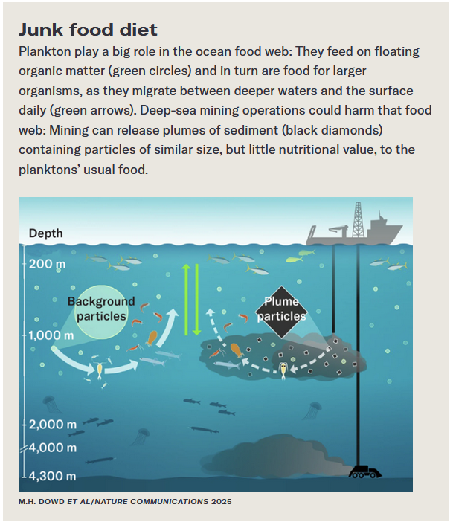
Graph Questions
1. Name the ecosystem disturbance illustrated in the diagram.

2. What is the depth of the plume of sediment particles shown in the diagram?
- 200-1000 m
- 1000-1500 m
- 2000-4000 m
- 4000-4300 m

3. What role does plankton play in the ocean food web?
- At the top of the food chain, as one of the large organisms that feed on smaller ones
- At the bottom of the food chain, as small organisms that are food for larger ones
- At the autotrophic level, performing photosynthesis to convert light energy to chemical energy

4. What is the danger of the plankton eating the plume particles instead of floating organic matter?

