Student Worksheet: Soil microbes during climate change
Directions: A warming world will impact bacteria, fungi and other microbes that play key roles in ecosystems. So researchers are working to understand how climate change will affect microbes — and if humans can harness them to reduce its impacts.
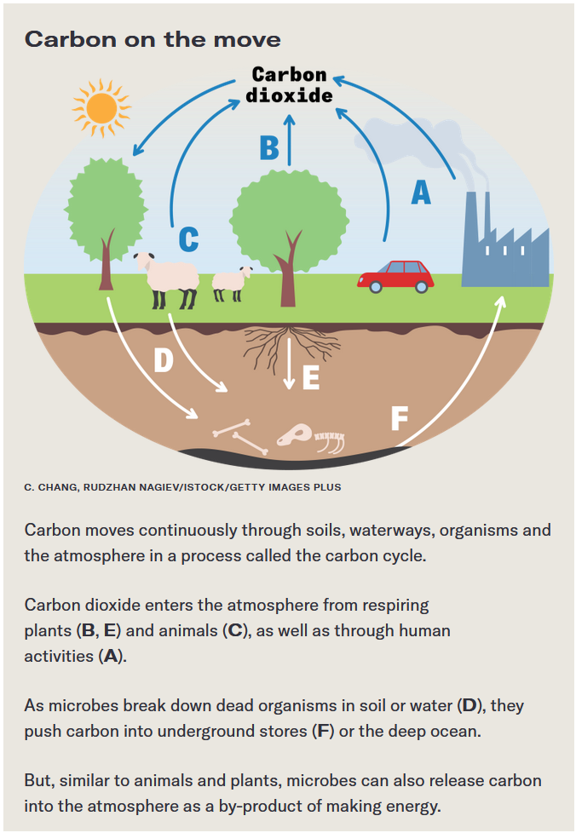
Graph Questions
1. Name three ways that carbon dioxide enters the atmosphere.

2. Name the process taking place in “D” in the diagram.

3. Based on your previous knowledge, what process do plants perform that removes carbon dioxide from the atmosphere?

4. Explain why the carbon cycle is a “cycle.”

