Student Worksheet: Why mid-size wins in speed
Directions: The relationship between speed and size has long stumped scientists. A study that surveyed how speed tracks with body size found that the make-or-break factor was the time it takes animals to achieve their theoretical top speed. Using the graph from the article below, please answer the following questions.

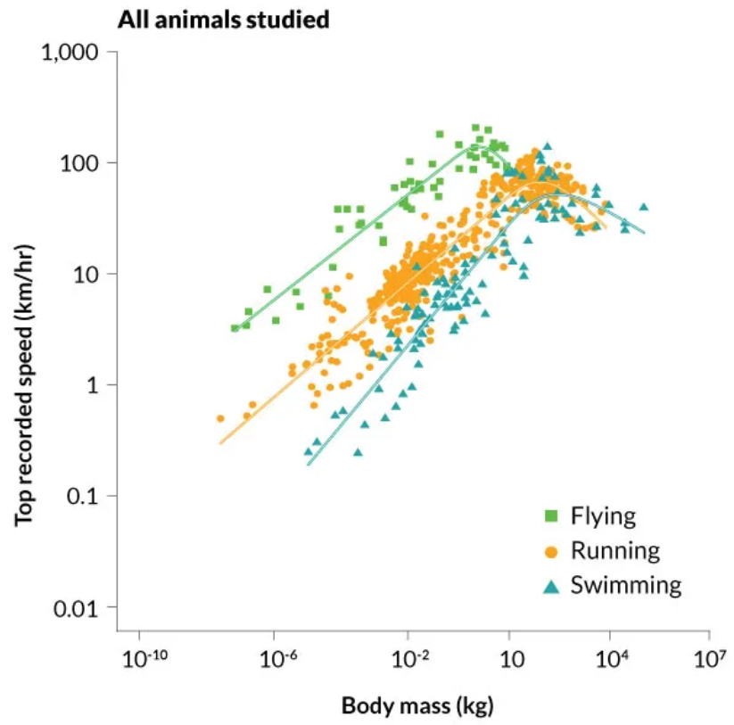
Graph Questions
1. Which mode of transportation has the top recorded speed?
- Flying
- Running
- Swimming

2. Which mode of transportation has the biggest difference between the slowest and fastest speed?
- Flying
- Running
- Swimming

3. At what body mass do animals who swim become not the slowest group of animals?

4. What does the graph tell you about how body mass relates to speed? Why might this be?

