Student Worksheet: Hurricanes level up
Directions: Human-caused climate change is boosting the intensity of Atlantic hurricanes. Using computer simulations, researchers calculated what wind speeds of recent hurricanes would have been without warming and then compared them with the hurricanes’ actual wind speeds. The team found that climate change boosted wind speeds by up to 47 kilometers per hour (28 miles per hour). Using the graph from the article (pictured below), please answer the following questions.

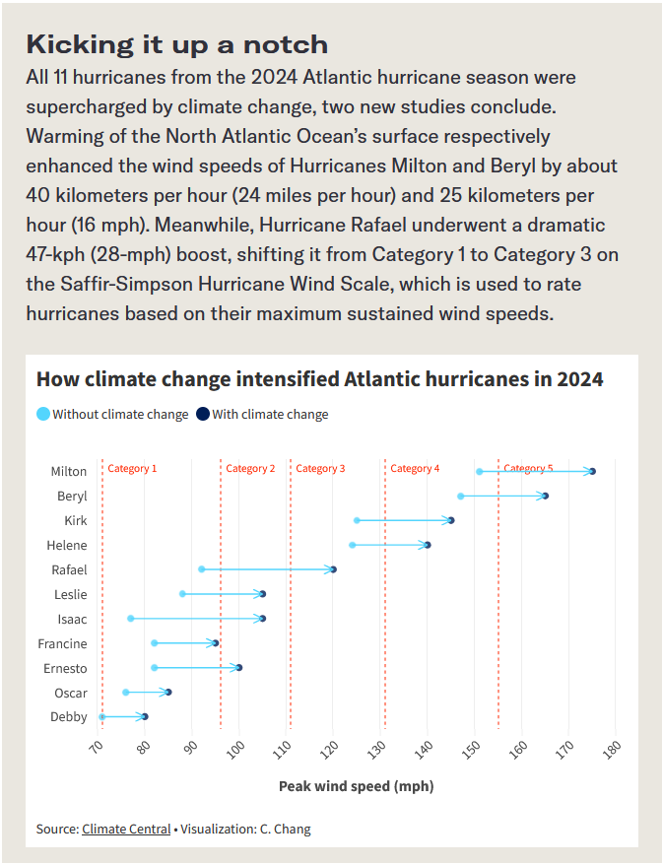
Graph Questions
1. What is the difference in wind speed (mph) for Hurricane Milton when comparing the speed with and without climate change?
- 10 mph
- 14 mph
- 21 mph
- 24 mph

2. Among the Category 1 hurricanes, what is the smallest difference in wind speed (mph) when comparing the speed with and without climate change?
- 6 mph
- 9 mph
- 17 mph
- 20 mph

3. Which hurricanes have the biggest difference in wind speed (mph) when comparing the speed with and without climate change?

4. How many of the listed hurricanes would have been at least one category lower in classification if climate change wasn’t a factor?

