Student Worksheet: Run like a rabbit
Running the Results
Record the data collected from the game “Run Like a Rabbit” before graphing the data and answering associated questions.
1. Record the number of “Rabbits” and “Foxes” present at the start of each round of the “Run Like a Rabbit” game in the table below. Include the final number of “Rabbits” and “Foxes” in your data. The final number is listed as the start of Round 21.

Run Like a Rabbit Data
Animal | Round
Animal | 1 | 2 | 3 | 4 | 5 | 6 | 7 | 8 | 9 | 10 | 11 | 12 | 13 | 14 | 15 | 16 | 17 | 18 | 19 | 20 | 21
Rabbits
Foxes | 0 | 0 | 0 | 0 | 0 | 0 | 0 | 0 | 0 | 0

2. Use the space below to graph your data. Use different colors for the “Rabbit” and “Fox” graphs, identifying each color in the provided key.
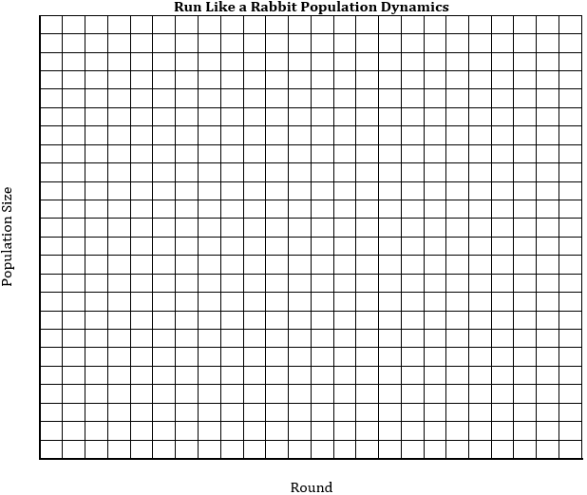

Key
Rabbits
Foxes

3. Consider what you know about ecosystems. What changes in the ecosystem is the game suggesting happened to the “Rabbits” when they could not find the resources they needed and to the “Foxes” when they could not catch a “Rabbit?” Why did they turn into “Resources” in the game?

4. Using your knowledge of ecosystems, what changes in the ecosystem is the game indicating happened to the “Resources” after they were taken by a “Rabbit” and the “Rabbits” after they were taken by a “Fox?”

Population Dynamics
Read the Science News article “In a Quebec park, a science game brings predator-prey dynamics to life” and answer the associated questions.

1. How is the game described in the article different from the game you played at the start of class?

2. Population dynamics is the study of how populations change over time. Which game do you think would model population dynamics more realistically? Why?

3. If you played several rounds of the game described in the article and graphed the numbers of prey, mesopredators and predators starting each round, do you think the graph would look the same or different from the graph you created? Why?

4. What survival tactics did the players use in the game described in the article?

Rules for Realism
Use a computer to find an article or other source about a tactic predators might use to catch prey or a tactic prey might use to avoid predators. You could use one of the three Science News articles linked in the Science News article “In a Quebec park, a science game brings predator-prey dynamics to life” or search the Science News article archives. Once you find a tactic you find interesting, answer the questions and follow the instructions on your student worksheet to create a new rule for the game “Run Like a Rabbit.”If there is enough time in class, students can move back to the large, open area to play “Run Like a Rabbit” and test their new rules.

1. Identify the article or alternate source you are using for this section of the activity.

2. Describe one “predator” or “prey” tactic that is mentioned in your article or alternate source but is not reflected in the game “Run Like a Rabbit.”

3. Create a new rule for the game that includes this tactic.

4. How does this tactic make the game more accurately reflect real-world population dynamics?

