Student Worksheet: Animal joy
Directions: For decades, scientists have struggled to identify or measure joy in animals. Better measurement of creatures’ positive emotions would allow scientists to make strides in studying the causes of happiness and how animals communicate it. So a team of researchers is trying to develop a “joy-o-meter,” a set of metrics to help understand animal emotions.

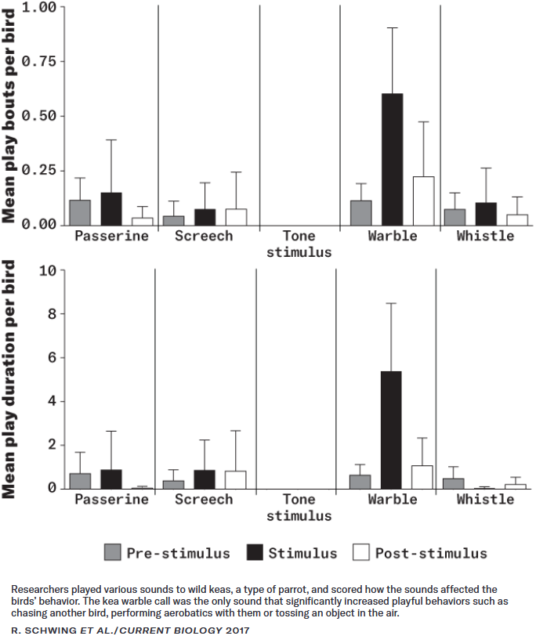
Graph Questions
1. After playing various sounds to wild keas, a type of parrot, scientists analyzed how the sounds affected the birds’ behavior. Which type of sound caused a significant increase in playful behavior?
- Passerine
- Screech
- Tone stimulus
- Warble
- Whistle

2. After which two sounds did the keas show a smaller amount of playful behavior than before the sounds were played?
- Passerine
- Screech
- Tone stimulus
- Warble
- Whistle

3. What is the average length of time that the keas played during the warble noise?

