Student Worksheet: Cats and their ancient 9 lives
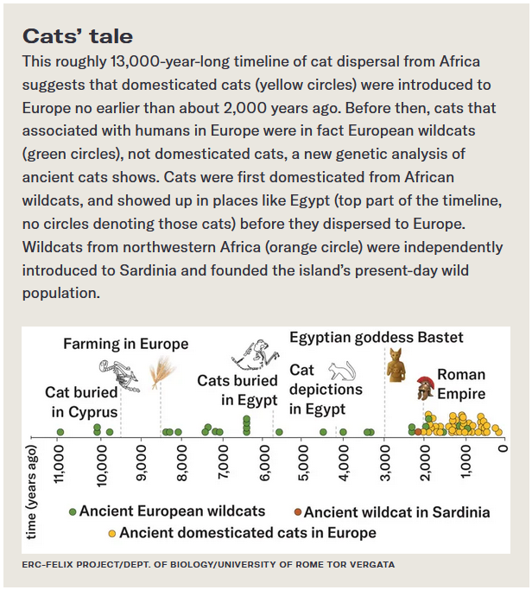
Directions: Like a toy on a string, the timing of cat domestication has been a moving target. Now researchers have pounced on a new timeline suggesting that tame descendants of African wildcats left the continent more recently than realized.
Graph Questions
1. According to the Cats’ tale timeline above, which category of cat is the oldest?
- Ancient European wildcats
- Ancient wildcat in Sardinia
- Ancient domesticated cats in Europe

2. When did ancient domesticated cats first appear in Europe?

3. What evidence exists that supports the presence of cats in ancient Egypt? Please give at least two examples of evidence.

