Student Worksheet: Hot Hot Hot!
Directions: The last three years were the hottest on record, a new analysis shows. It was also the first three-year-period in which average global temperatures exceeded 1.5 degrees Celsius above preindustrial levels. That threshold coincides with weather extremes and increased risks to biodiversity and human health.
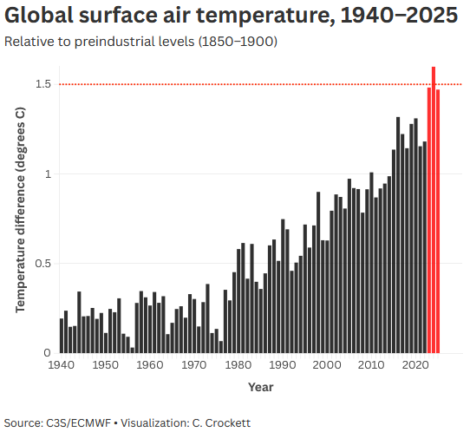
Graph Questions
1. What timespan is being used as the baseline to which global surface air temperatures are compared?

2. In what decade was the lowest temperature difference relative to preindustrial levels?
- 1940s
- 1950s
- 1960s
- 1970s
- 1980s

3. In what decade did the temperature difference reach 1.5°C above preindustrial levels?
- 1980s
- 1990s
- 2000s
- 2010s
- 2020s

4. In what year did the temperature difference first reach 1°C above preindustrial levels?
- 1980
- 1990
- 2000
- 2010
- 2020

5. In your opinion, what is one topic that could be contributing to the increased temperatures on the planet?

